Information memorandum

Full and short name of JSC: JSC " Snitovo -Agro"

Address (location): Brest region, Ivanovsky district, Snitovo ag ., Sovetskaya 3 st.

Website, e-mail: snitovo@gmail.com

State registration data:

Information about the management of the organization, contact numbers:
Director - Glinnik Sergey Anatolyevich (2 years experience in this position) tel.
Chief Accountant – Galushko Natalya Grigoryevna (experience 12 years in this position)
tel. 8 016 52 38 286, 8 029 180 40 69

I. General information about the organization
The history of the creation of JSC " Snitovo -Agro" originates from the collective farm "Young Guard", organized in 1949.
SC "Young Guard" was organized in 1992 as a result of the reorganization of the collective farm "Young Guard", organized in 1949. SPK " Snitovo -Agro" was organized in 2003 on the basis of the agricultural cooperative "Young Guard" of the Ivanovo district. SPK " Snitovo -Agro" is the legal successor of the rights and obligations of IC "Young Guard". In 2005, SPK Snitovo -Agro acted as the buyer of the property complex of the RUSPP Ivanovo Breeding Bird Reproductor and the assignee of its rights and obligations. In 2016, on December 28, SPK Snitovo -Agro was reorganized into OJSC Snitovo -Agro with a 100% state share.
The administration of JSC " Snitovo -Agro" is located in the village of Snitovo (11 km from the regional center of Ivanovo). In addition to the village of Snitovo , the cooperative includes a part of the city limits of Ivanovo and the village of Vorotsevichi , located 3 km from the central estate.
The highway Brest - Gomel and the railway line with the message Brest - Pinsk - Luninets run through the territory of the OJSC, connecting the economy with the sales markets.
JSC " Snitovo -Agro" is a multi-specialized agricultural production. The main activity of the economy is meat and dairy production. The cooperative carries out the production, procurement, storage and sale of agricultural products (milk, meat, eggs, sugar beet, grain, etc.).
The economic activity of the economy includes the production of livestock, poultry, beekeeping and crop production.
At the beginning of 2023, the total land area is 6,261 hectares. Total agricultural land - 5,640 ha, including arable land - 3,646 ha, hayfields - 321 ha, pastures - 1,655 ha. farmland score - 33.5 points , arable land - 34.4 points .
The organizational structure of the farm is represented in crop production by 3 field-growing brigades " Snitovo ", " Mogilno ", " Vorotsevichi ", 3 livestock farms, which, as of 01/01/2022, contained 3,904 heads of cattle, including 1,315 cows , a poultry farm with an average annual population of 67,059 laying hens.
The current state of the enterprise. In recent years, the economy of the economy has acquired the character of sustainable development. JSC " Snitovo -Agro" in its work has chosen as a priority the widespread introduction of intensive technologies aimed at increasing production, reducing the cost of its production, technical re-equipment of production, improving the standard of living of farm workers.

II. Financial indicators of economic activity of the organization
Index | 2020 | 2021 | 202 2
The value of net assets, thousand rubles. | 19 035 | 19 960 | 36 815
Revenue from the sale of products, works, services, thousand rubles | 17 744 | 18 421 | 23 739
Total profit (line 150 of the income statement), thousand rubles | 1 923 | 977 | 2907
Profit from the sale of products, works, services, thousand rubles. | 2566 | 1 866 | 3077
Net profit , thousand rubles | 1953 | 977 | 2907
Profitability of sold products, works, | 18.9 | 12 , 6 | 16.9
services , % | 336 | 462 | 697
Accounts receivable *, thousand rubles | 4091 | 5473 | 4 982
Accounts payable *, thousand rubles | 1,092.9 | 1316.7 | 1416.56

III. Enlarged nomenclature of manufactured products, works, services rendered.

Information about manufactured products, performed works, rendered services:

products , works , services  ( by type ) | Issue volume | year
products , works , services  ( by type ) | Issue volume | 2020 | 2021 | 202 2
Milk production | tons | 12 267 | 12 588 | 12 875
Production of cattle and poultry meat | tons | 760 |  | 797
egg production | thousand pieces | 15 420 | 12 916 | 15 577
Production of grains and pulses (weight after completion) | tons | 6 827 | 6 301 | 7085
Grain corn production | tons | 2610 | 2203 | 1460
sugar beet production | tons | 5 527 | 5 345 | 3 575
open field vegetable production | tons | - | - | -
Rape seed production | tons | 831 | 646 | 1 184
fruits production | tons | 51 | 104 | 434

IV. implemented investment projects.
The need for investment is due to the need to improve the efficiency of the enterprise by creating new production facilities with a corresponding increase in the production of milk, meat and poultry products.

V. _ structure of employees :

 | Age |  |  |  |  |  |  | Total
 | -25 | 25-35 | 35-40 | 40-45 | 45-50 | 50-55 | 55+ | Total
Number , include . | 34 | 42 | 33 | 52 | 58 | 38 | 51 | 306
- number of employees with higher education | 3 | 8 | 7 | 3 | 2 | 6 | 10 | 39
-with _ secondary special education | 14 | 6 | 5 | eleven | 10 | 14 | 8 | 68
-with _ vocational education | 15 | 13 | 8 | 12 | 20 | 12 | 14 | 94
-with _ secondary education | 2 | eleven | 10 | 18 | 24 | 6 | 13 | 84
- with basic education | - | 4 | 3 | 8 | 2 | - | 6 | 23

Total number of employees : | 306
- the number of management apparatus | 59
- the number of industrial and production personnel, | 247
including number of key workers | 247

VI . The structure of the implementation of works (services):

Structure ( in %) | 2020 | 2021 | 2022
domestic market | 100 | 100 | 100
External market
Total | 100 | 100 | 100

All products are sold on the territory of the Republic of Belarus.

VII. Information on land plots in use, lease, ownership:
Location of the site | Area, ha | Right (permanent/temporary use, lease, ownership) | Land use act (No., date)
Republic of Belarus, Brest region, Ivanovsky district, Snitovsky village, 14 | 9.7141 | permanent use | Notice of amendments to the documents of the unified state register of real estate, rights to it and transactions with it No. 2567 / 11: 754 dated 06/22/2011
Republic of Belarus, Brest region, Ivanovsky district, Snitovsky s / s | 0.7774 | permanent use | No. 132/754-3216 dated 11/13/2008
Republic of Belarus, Brest region, Ivanovsky district, Snitovsky s / s, ag . Snitovo, Sovetskaya st. , 3 | 0.1593 | rent | No. 132/1394-30 dated 08/13/2012
Republic of Belarus, Brest region, Ivanovsky district, Snitovsky s / s, ag . Snitovo, Sovetskaya st. , 1 | 0.0298 | rent | No. 132/1394-29 dated 13.08.2012
Republic of Belarus, Brest region, Ivanovsky district, Snitovsky village, southwest of Ivanovo | 0.3441 | permanent use | No. 132/1431-169 dated 09/21/2012
Republic of Belarus, Brest region, Ivanovsky district, Ivanovo , st. Komsomolskaya, 70 A | 1.3477 | permanent use | Notice of amendments to the documents of the unified state register of real estate, rights to it and transactions with it No. 1990 / 11: 754 dated 05/17/2011
Republic of Belarus, Brest region, Ivanovsky district, Snitovsky s / s, 4.5 kilometers north-east of the village of Snitovo | 3.2649 | permanent use | No. 132/754-9124 dated 12/12/2011
Republic of Belarus, Brest region, Ivanovsky district, Snitovsky village, 4.5 kilometers northeast of the village of Snitovo | 1.2124 | permanent use | No. 132/754-7243 dated 12/08/2010
Republic of Belarus, Brest region, Ivanovsky district, Snitovsky village, 0.1 km west of Ivanovo | 0.4893 | permanent use | No. 132/332-87 dated 06/27/2012
Republic of Belarus, Brest region, Ivanovsky district, Snitovsky s / s, 500 meters north of the village of Vorotsevichi | 6.0409 | permanent use | No. 132/754-8504 of 07/14/2011
Republic of Belarus, Brest region, Ivanovsky district, Snitovsky village, 0.3 km north of the village. Vorotsevichi | 1.3412 | permanent use | No. 132/228/21 of 07/17/2012
Republic of Belarus, Brest region, Ivanovsky district, Ivanovo, st. Barsky, d. 10b | 11.0387 | permanent use | No. 132/754-7244 dated 12/08/2010
d. Trudovaya | 3.6355 | permanent use | No. 132/1431-8764 dated 08/31/2016
Republic of Belarus, Brest region, Ivanovsky district, Snitovsky s / s, 800 m south of the village of Trudovaya | 0.2800 | permanent use | No. 132/754-8703 dated 08/19/2011
Republic of Belarus, Brest region, Ivanovsky district | 207.7281 | permanent use | No. 132/754-6665 of 08/25/2010
Republic of Belarus, Brest region, Ivanovsky district, Snitovsky s / s, northeast of the village of Snitovo , section No. 1 | 35.2942 | permanent use | No. 132/1431-1781 dated 06/22/2013
Republic of Belarus, Brest region, Ivanovsky district, Snitovsky village, west of the village of Trudovaya, section No. 2 | 17.3838 | permanent use | No. 132/1431-1780 dated 06/22/2013
Republic of Belarus, Brest region, Ivanovsky district, Snitovsky s / s, northeast of the village of Snitovo , section No. 3 | 105.4832 | permanent use | No. 132/1431-1779 dated 06/22/2013
Republic of Belarus, Brest region, Ivanovsky district, Snitovsky village, east of the village of Snitovo , section No. 4 | 39.1871 | permanent use | No. 132/1431-1778 dated 06/22/2013
Republic of Belarus, Brest region, Ivanovsky district, Snitovsky village, east of the village of Snitovo , section No. 5 | 7.8662 | permanent use | No. 132/1431-1777 dated 06/22/2013
Republic of Belarus, Brest region, Ivanovsky district, Snitovsky s / s, adjacent to the village of Vorotsevichi , section No. 6 | 1188.7197 | permanent use | No. 132/1646-8238 of 07/08/2022
Republic of Belarus, Brest region, Ivanovsky district, Snitovsky village, west of the village of Snitovo , section No. 7 | 764.0395 | permanent use | No. 132/1310-10280 dated 06/17/2020
Republic of Belarus, Brest region, Ivanovsky district, Snitovsky s / s, adjoins the ag . Snitovo, plot №8 | 43.3638 | permanent use | No. 132/1310-9731 of 03/17/2020
Republic of Belarus, Brest region, Ivanovsky district, Snitovsky village, east of the village of Snitovo , section No. 9 | 211.2583 | permanent use | No. 132/1431-1773 dated 06/22/2013
Republic of Belarus, Brest region, Ivanovsky district, Snitovsky village, east of the village of Snitovo , section No. 10 | 290.2250 | permanent use | No. 132/1431-1772 dated 06/22/2013
Republic of Belarus, Brest region, Ivanovsky district, Snitovsky village, east of the village of Snitovo , section No. 11 | 346.5471 | permanent use | No. 132/1431-1771 dated 06/22/2013
Republic of Belarus, Brest region, Ivanovsky district, Snitovsky s / s, north of the village of Snitovo , section No. 12 | 393.6090 | permanent use | No. 132/1431-1770 dated 06/22/2013
Republic of Belarus, Brest region, Ivanovsky district, Snitovsky s / s, adjacent to the village of Vorotsevichi , section No. 13 | 0.3267 | permanent use | No. 132/1431-1769 dated 06/22/2013
Republic of Belarus, Brest region, Ivanovsky district, Snitovsky village, south of the village of Snitovo , section No. 14 | 1475.1147 | permanent use | No. 132/1431-1768 dated 06/22/2013
Brest region Ivanovsky district, Gorbakhsky s / s, ag . Snitovo, st. Novaya, d. 2B | 0.1407 | permanent use | No. 132/1431-1257 dated 04/08/2013
Brest region Ivanovsky district, Gorbakhsky s / s, ag . Snitovo, st. Novaya, d. 2G | 0.1547 | permanent use | No. 132/1431-1258 of 04/08/2013
Brest region Ivanovsky district, Gorbakhsky s / s, ag . Snitovo, st. New, d. 2D | 0.1466 | permanent use | No. 132/1431-1256 of 04/08/2013
Brest region Ivanovsky district, Ivanovo , st. Shevchenko, d.8-2 | 0.1492 | rent | No. 132/754-6664 dated 08/25/2010
Brest region Ivanovsky district, Snitovsky s / s, Snitovo village, st. Leninskaya, 36, apt. 2 | 0.1216 | rent | No. 132/1431-4017 dated 09/10/2014
Brest region, Ivanovsky district, village Vorotsevichi , st. Krupskoy, 36 | 0.5446 | permanent use | No. 132/275-987 dated 11/22/2005
Brest region, Ivanovsky district, Snitovsky s / s, village Vorotsevichi , st. Krupskoy, 47 | 0.2498 | rent | No. 132/754-7353 dated 12/18/2010
Brest region, Ivanovsky district, Snitovsky s / s, village Vorotsevichi , st. Sadovaya, 9 | 0.2417 | rent | No. 132/754-6921 dated 09/28/2010
Brest region, Ivanovsky district, Snitovsky s / s, village Vorotsevichi , st. Krupskoy, 115 | 0.2500 | permanent use | No. 132/754-1521 dated 11/10/2007
Brest region, Ivanovsky district, Snitovsky s / s, village Vorotsevichi , st. Krupskoy, 123 | 0.2500 | permanent use | No. 132/754-1522 dated 11/10/2007
Brest region, Ivanovsky district, Snitovsky s / s, village Vorotsevichi , st. Krupskoy, 112 | 0.2356 | rent | No. 132/754-7352 dated 12/18/2010
Brest region, Ivanovsky district, Snitovsky s / s, village Vorotsevichi , st. Krupskoy, 106 | 0.2500 | permanent use | No. 132/754-1519 dated 11/10/2007
Brest region, Ivanovsky district, Snitovsky s / s, village Vorotsevichi , st. Krupskoy, 102 | 0.2500 | permanent use | No. 132/754-1518 dated 11/10/2007
Brest region, Ivanovsky district, Snitovsky s / s, village Vorotsevichi , st. Krupskoy, 100 a | 0.2499 | permanent use | Notice of amendments to the documents of the unified state register of real estate, rights to it and transactions with it No. 340/16 dated 04/29/2016
Brest region, Ivanovsky district, Snitovsky s / s, village Vorotsevichi , st. Krupskoy, d.97A | 0.2476 | rent | No. 132/754-7350 dated 12/18/2010
Brest region, Ivanovsky district, Snitovsky s / s, village Vorotsevichi , st. Krupskoy, 117 | 0.2500 | permanent use | No. 132/1431-168 dated 09/21/2012
Brest region Ivanovsky district, Snitovsky s / s, Snitovo village, st. Leninskaya, 33 | 0.2522 | permanent use | No. 132/754-5840 of 05/25/2010
Brest region Ivanovsky district, Snitovsky s / s, ag . Snitovo, st. Sovetskaya, d. 7A | 0.2479 | rent | No. 132/754-8413 dated 06/08/2011
Brest region Ivanovsky district, Snitovsky s / s, Snitovo village, st. Komsomolskaya, 38b | 0.1300 | permanent use | No. 132/754-4828 of 10/15/2009
Brest region Ivanovsky district, Snitovsky s / s, Snitovo village, st. Polevaya, 5 | 0.1521 | rent | No. 132/754-6662 dated 08/24/2010
Brest region Ivanovsky district, Snitovsky s / s, Snitovo village, st. Field, d.2b | 0.1291 | permanent use | No. 132/754-3093 dated 10/11/2008
Brest region Ivanovsky district, Snitovsky s / s, Snitovo village, st. Novaya, d. 26 | 0.1424 | permanent use | No. 132/754-4139 of 05/26/2009
Brest region Ivanovsky district, Snitovsky s / s, Snitovo village, st. Komsomolskaya, 38a | 0.1319 | permanent use | No. 132/754-4834 of 10/16/2009
Brest region Ivanovsky district, Snitovsky s / s, ag . Snitovo, st. Polevaya, d.1 | 0.1408 | rent | No. 132/754-6657 dated 08/26/2010
Brest region Ivanovsky district, Snitovsky s / s, Snitovo village, st. Leninskaya, d. 57b | 0.1480 | permanent use | No. 132/754-3091 dated 10/11/2008
Brest region Ivanovsky district, Snitovsky s / s, ag . Snitovo, st. Molodogvardeyskaya, 11 | 0.2500 | rent | No. 132/754-9282 dated 01/17/2012
Brest region Ivanovsky district, Gorbakhsky s / s, ag . Snitovo, st. Polevaya, 9 | 0.1518 | permanent use | No. 132/1431-1856 dated 08/14/2013
Brest region Ivanovsky district, Snitovsky s / s, 0.3 kilometers south of the village. Snitovo | 2.2260 | permanent use | No. 132/754-5720 dated 05/11/2010
Brest region Ivanovsky district, Snitovsky s / s, west of the village of Snitovo , section No. 7 | 764.1386 | permanent use | No. 132/1431-9975 of 07/14/2017
Brest region Ivanovsky district, Snitovsky s / s, village Vorotsevichi 48 Krupskaya St. (shop) | 0.0897 | permanent use | No. 132/1310-10401 of 08/04/2020
Brest region Ivanovsky district, Odrizhinsky s / s, near the village of Korsyn | 233.0751 | permanent use | No. 132/1646-6225 dated 04/29/2021
Brest region Ivanovsky district, Odrizhinsky s / s, southeast of the village of Korsyn , section No. 1 | 382.4517 | permanent use | No. 132/1646-6224 dated 04/29/2021
Brest region Ivanovsky district, Odrizhinsky s / s, near the village of Korsyn , section No. 1 | 191.7931 | permanent use | No. 132/1646-6223 dated 04/29/2021
Brest region Ivanovsky district, Odrizhinsky s / s, near the village of Korsyn , section No. 2 | 316.1143 | permanent use | No. 132-1646-6222 dated 04/29/2021
Brest region Ivanovsky district, Snitovsky s / s, north of the village of Snitovo , section No. 12 | 393.5587 | permanent use | No. 132/1646-5545 of 02/09/2021

VIII . Information on permanent structures (buildings, structures):
Photo |  | Name (appointment), location, registration certificate (No., date) |  | Year of construction | number of storeys | Area, m ² | Leased area, m ² , term of the lease agreement | General state *
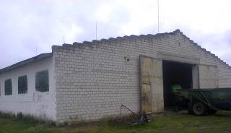 |  | 34 | auto garage  (Ivanovo, Barskogo st., 10B, No. 132/754-7249 dated December 13, 2010) | 12/30/1991 |  | 622.1 | -
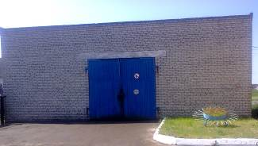 |  | 5343 | Aggregate br.1 (ag. Snitovo) | 12/31/1987 |  | 16.0 | -
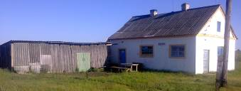 |  | 4032 | Bath br. 3 (v. Vorotsevichi) | 12/31/2014 |  | - | -
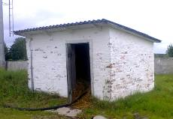 |  | 6 | Pump booth (Ivanovo, Komsomolskaya st.) | 12/01/1974 |  | 25.0 | -
 | 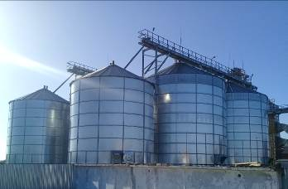 | 3785-1 | Bunker for grain storage with a capacity of 1000 tons (Ivanovo, Komsomolskaya St., No. 132/1392-217 dated 05/29/2012) | 12/31/2010 |  | - | -
 |  | 3785-2 | Bunker for grain storage with a capacity of 1000 tons (Ivanovo, Komsomolskaya St., No. 132/1392-217 dated 05/29/2012)
 |  | 3785-3 | Bunker for grain storage with a capacity of 1000 tons (Ivanovo, Komsomolskaya St., No. 132/1392-217 dated 05/29/2012)
 |  | 3785-4 | Bunker for grain storage with a capacity of 1000 tons (Ivanovo, Komsomolskaya St., No. 132/1392-217 dated 05/29/2012)
 |  | 3785-5 | Bunker for grain storage with a capacity of 500 tons (Ivanovo, Komsomolskaya St., No. 132/1392-217 dated 05/29/2012)
 |  | 3785-6 | Bunker for grain storage with a capacity of 500 tons (Ivanovo, Komsomolskaya St., No. 132/1392-217 dated 05/29/2012)
 | 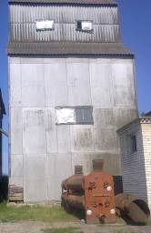 | 2831 | Ventilated bunkers OBV-160  (ag. Snitovo) | 12/31/1990 |  | - | -
 | 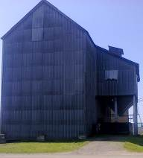 | 2965 | Ventilated bunkers OBV-160  (ag. Snitovo) | 12/31/1991 |  | - | -
 | 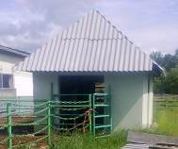 | 4024 | Weight (Ivanovo) | 03/01/2012 |  | - | -
 | 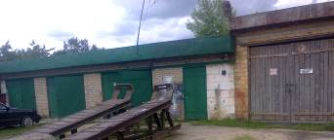 | 0118 | Garage for cars br.2 (Ivanovo) | 12/30/1978 |  | 152.0 | -
 | 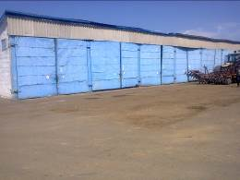 | 0120 | Garage for storage of agricultural machines br.1  (ag. Snitovo) | 12/31/1979 |  | 825.0 | -
 | 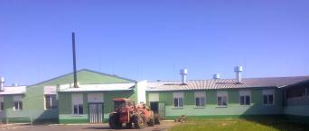 | 3975-1 | Milking and milk block br.3  (v. Vorotsevichi) | 21.10.2014 |  | - | -
 | 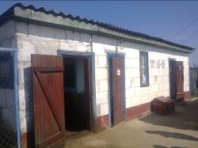  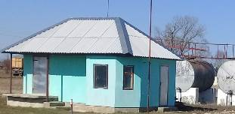 | 3069 | Refueling br.1  (ag. Snitovo) | 12/31/1992 |  | - | - | Overhaul underway
 | 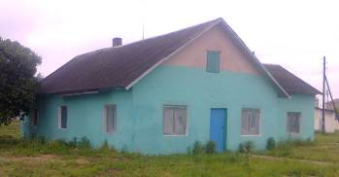 | 7 | Wet block building  (Ivanovo, Barskogo st., 10B, No. 99 dated 06/06/2001) | 12/01/1963 |  | 101.0 | -
 | 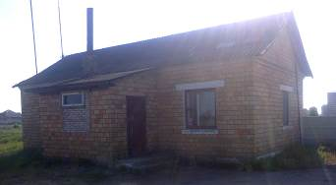 | 0141 | Control room building br.1  (ag. Snitovo) | 12/31/1982 |  | 70.0 | -
 | 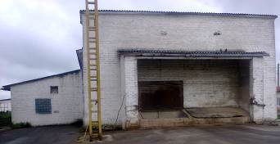 | 8 | Feed shop building (young)  (Ivanovo, Komsomolskaya st.) | 12/01/1974 |  | 310.0 | -
 | 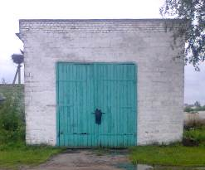 | 5 | Boiler house building PU (young)  (Ivanovo, Komsomolskaya st.) | 12/01/1974 |  | 87.0 | -
 | 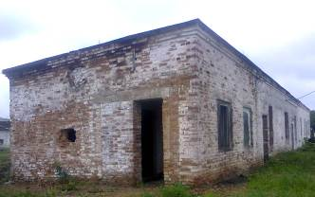 | 4 | Boiler building PU (center)  (Ivanovo, Barskogo st., 10B) | 12/01/1969 |  | 139.0 | -
 | 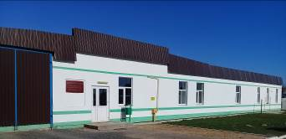 | 31 | Household building  (Ivanovo, Barskogo st., 10B, No. 132/1431-242 of 03.10.2012) | 12/30/1989 |  | 257.5 | -
 | 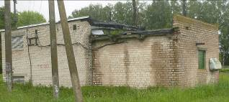 | 32 | diesel building  (Ivanovo, Barskogo st., 10B, No. 97 of 06/06/2001) | 12/30/1989 |  | 23.0 | -
 | 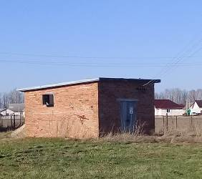 | 621 | diesel building  (Ivanovo, Komsomolskaya st., No. 88 of 06/06/2001) | 07/01/1982 |  | 24.0 | -
 | 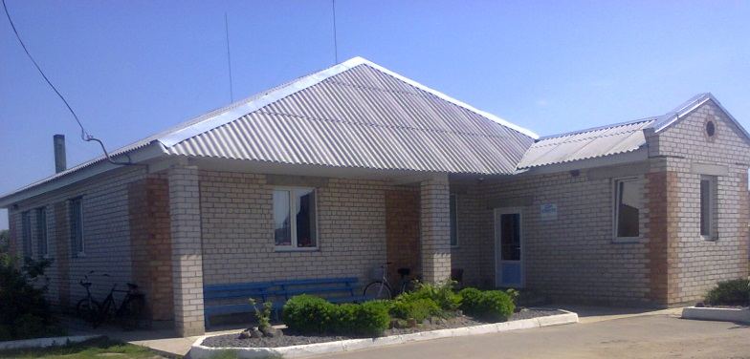 | 0141a | Control room building br.1  (ag. Snitovo) | 01.12.2010 |  | - | -
 | 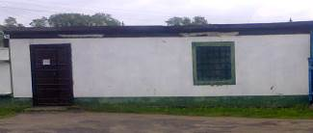 | 628 | Container storage building  (Ivanovo, Barskogo st., 10B, No. 77 dated 06.06.2001) | 07/01/1994 |  | 32.0 | -
 | 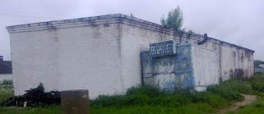 | thirty | shower building  (Ivanovo, Barskogo st., 10B, No. 98 dated 06/06/2001) | 06/01/1989 |  | 55.0 | -
 | 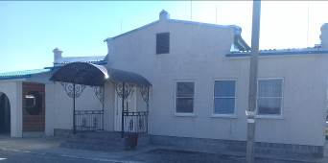 | 3939 | Cafe building (ag. Snitovo) | 11/29/2013 |  | - | - | Reconstruction underway
 | 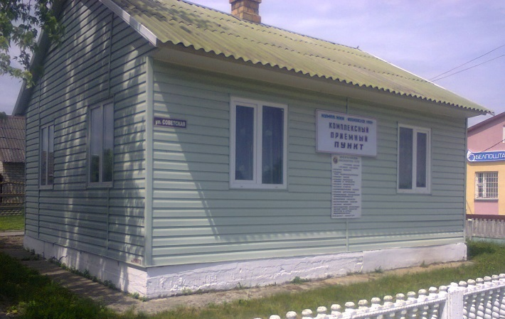 | 0073 | KBO building  (ag. Snitovo) | 01/01/1968 |  | 59.0 | -
 | 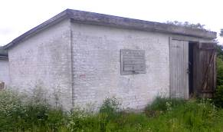 | 629 | Brick building No. 13  (Ivanovo, Barskogo st., 10B, No. 78 dated 06/06/2001) | 07/01/1960 |  | 29.0 | -
 | 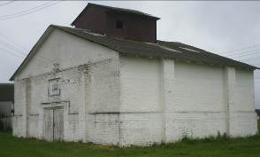 | 9 | Concent building. fodder  (Ivanovo, Barskogo st., 10B, No. 84 dated 06.06.2001) | 12/01/1965 |  | 150.0 | -
 | 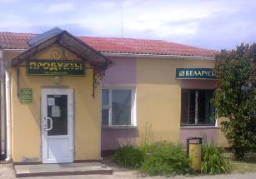 | 0093 | Shop building br.1  (ag. Snitovo, street Sovetskaya, 3  No. 132/1431-51 of 09/04/2012) | 12/01/1971 |  | 111 | 20.9 m ² until 12/01/2018
 | 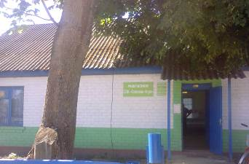 | 2595 | Shop building br.3  (v. Vorotsevichi) | 12/31/1988 |  | - | -
 | 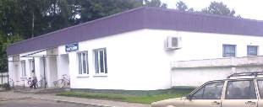 | 23 | PU shop building  (Ivanovo, Barskogo st., 10B, No. 132/1392-257 of 06/01/2012) | 12/01/1973 |  | 221.9 | -
 | 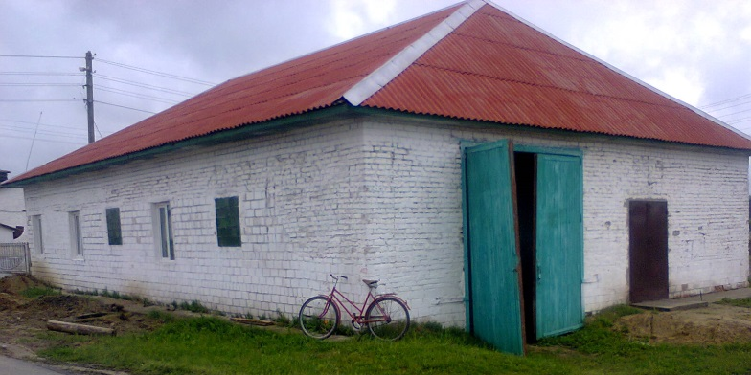 | 14 | washing building  (Ivanovo, Komsomolskaya st., No. 96 dated 06.06.2001) | 12/01/1974 |  | 195.0 | -
 | 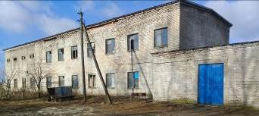 | 0111 | OKC building br.1  (ag. Snitovo) | 12/31/1975 |  | 140.0 | -
 | 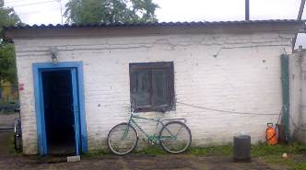 | 22 | Gatehouse building  (Ivanovo, Barskogo st., 10B, No. 83 dated 06.06.2001) | 12/01/1974 |  | 20.0 | -
 | 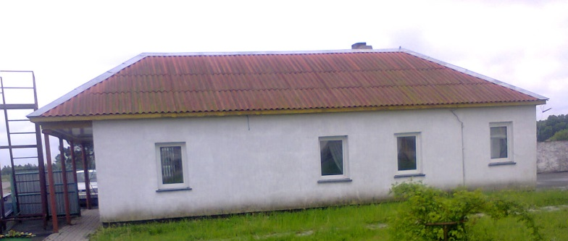 | 623 | Gatehouse building  (Ivanovo, Komsomolskaya st., No. 90 dated 06.06.2001) | 07/01/1981 |  | 34.0 | -
 | 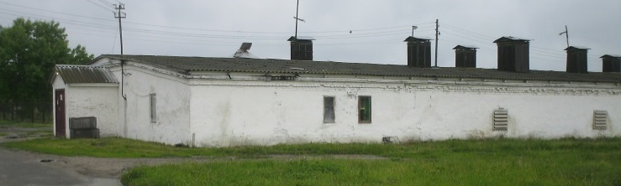 | eleven | Poultry building No. 1  (Ivanovo, Barskogo st., 10B, No. 132/1431-130 dated September 20, 2012) | 12/31/1963 |  | 1695.5 | -
 | 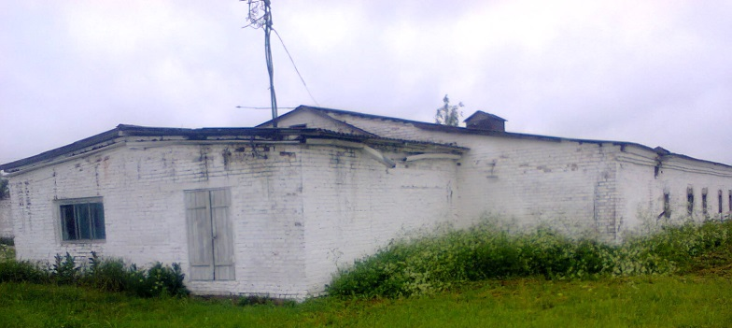 | 15 | Poultry building No. 4  (Ivanovo, Barskogo st., 10B) | 12/01/1969 |  | 1115.0 | -
 | 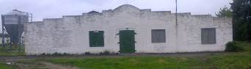 | 16 | Poultry building No. 5  (Ivanovo, Barskogo st., 10B) | 12/01/1971 |  | 1297.0 | -
 | 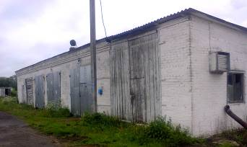 | 24 | tractor garage building  (Ivanovo, Barskogo st., 10B, No. 86 of -06.06.2001) | 12/01/1967 |  | 208.0 | -
 | 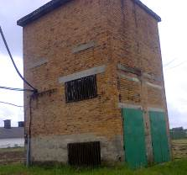 | 26 | Transformer substation building  (Ivanovo, Komsomolskaya st., No. 92 of 06/06/2001) | 12/01/1975 |  | 20.0 | -
 | 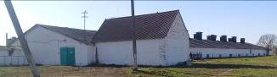 | 18 | Chicken house building No. 1  (Ivanovo, Komsomolskaya st.) | 12/01/1965 |  | 1668.0 | -
 | 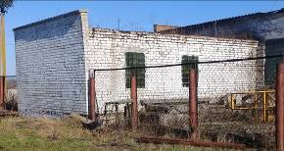 | 33 | Electric boiler building  (Ivanovo, Komsomolskaya st., No. 95 dated 06/06/2001) | 12/30/1991 |  | 53.0 | -
 | 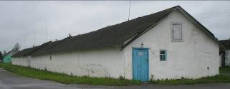 | 17 | egg store building  (Ivanovo, Barskogo st., 10B, No. 81 dated 06.06.2001) | 12/01/1963 |  | 239.0 | -
 | 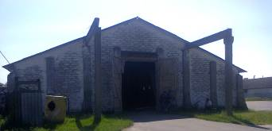 | 0117 | Granary br.1 (ag. Snitovo) | 01/01/1978 |  | 1296.0 | -
 | 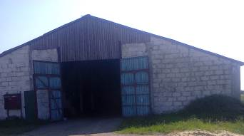 | 0110 | Granary br.1 (ag. Snitovo) | 12/31/1975 |  | 1296.0 | -
 | 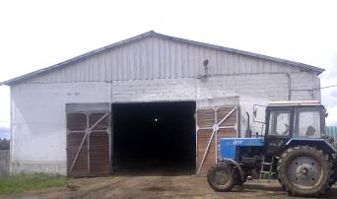 | 3248 | Grain warehouse br.2 (Ivanovo) | 12/31/1993 |  | 1210.0 | -
 | 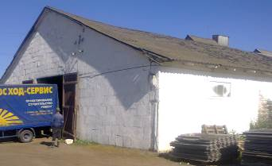 | 0086 | Granary br. 3 (v. Vorotsevichi) | 01/01/1975 |  | 650.0 | -
 | 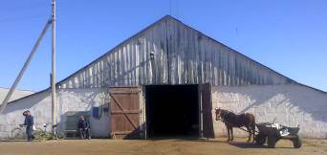 | 0087 | Granary br. 3 (v. Vorotsevichi) | 12/01/1973 |  | 650.0 | -
 | 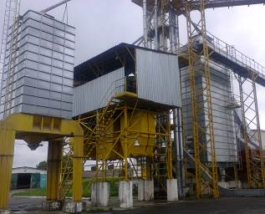 | 3763a | Grain drying complex KZSV-40-G-N  (Ivanovo, Komsomolskaya st., No. 132/754-9683 dated April 4, 2012) | 08/31/2010 |  | - | -
 | 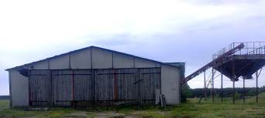 | 2833 | Potato sorting point KSP-25 br.1  (ag. Snitovo) | 12/31/1990 |  | - | -
 | 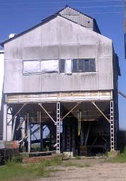 | 2830 | KZS-25 br.1  (ag. Snitovo) | 12/31/1990 |  | - | -
 | 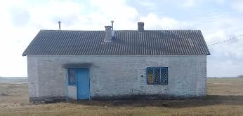 | 3066 | Sausage shop br.1  (ag. Snitovo) | 12/31/1992 |  | 110.0 | -
 | 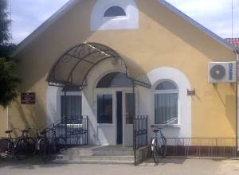 | 0074a | Office br. 1  (ag. Snitovo, street Sovetskaya, 3  No. 132/1431-51 of 09/04/2012) | 12/01/1969 |  | 351.7 | 28.7 m ² until 12/31/2017  15.7 m ² until 03/31/2017  10.5 m ² until 12/31/2017
 | 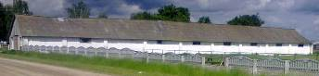 | 0017 | Stable br.2 (Ivanovo) | 12/01/1958 |  | - | -
 | 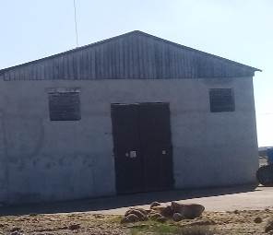 | 0128 | Root storage br.1  (ag. Snitovo) | 01/01/1980 |  | 1890.0 | -
 | 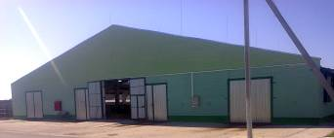 | 3947 | Cowshed No. 1 for 300 heads br.3 | 12/30/2013 |  | - | -
 | 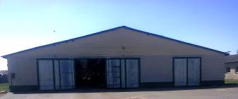 | 3670 | Loose barn for cows with DMB br.1  (ag. Snitovo, No. 132/754-3269 dated 11/17/2008) | 12/22/2007 |  | 2195.7 | -
 | 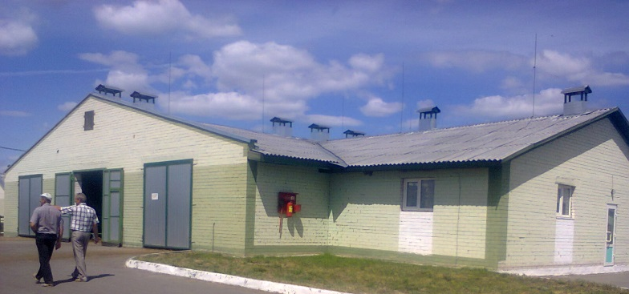 | 0145 | Loose barn with DMB br.3 (pos. 12 according to GP)  (v. Vorotsevichi) | 12/01/1983 |  | 1327.9 | -
 | 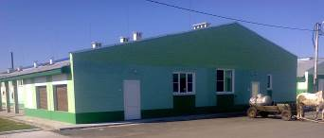 | 4000 | Box barn for 120 heads | 08/06/2015 |  | 1494.0 | -
 | 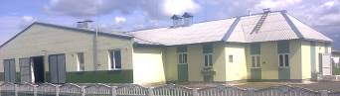 | 5318 | Cowshed br 2  (Ivanovo, No. 132/754-7250 dated 12/13/2010) | 12/30/1985 |  | 1571.0 | -
 | 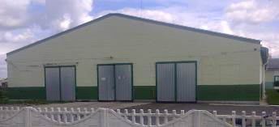 | 0140 | Cowshed br.2  (Ivanovo, No. 132/754-7250 dated 12/13/2010) | 12/30/1982 |  | 1872.0 | -
 | 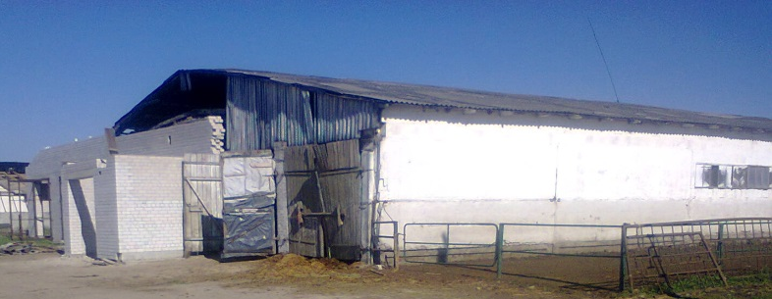 | 0130 | Cowshed for 120 heads (calf fattener) br.3  (v. Vorotsevichi, No. 132/754-9212 dated December 29, 2011) | 12/30/1980 |  | 1507.5 | - | Reconstruction of a cowshed for 120 heads for a calf
 | 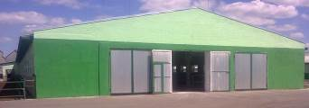 | 0075 | Cowshed for 160 heads br3  (v. Vorotsevichi, No. 132/1431-6614 dated 08/15/2015) | 12/01/1971 |  | 1594.0 | - | Overhaul of a cowshed for 160 heads
 | 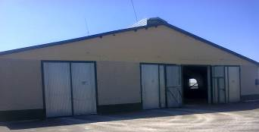 | 5267 | Cowshed for 192 heads of br.1  (ag. Snitovo) | 06/01/1986 |  | - | -
 | 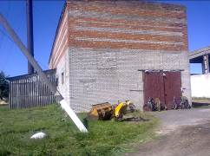 | 0125 | Boiler room of the complex br.1  (ag. Snitovo) | 12/31/1979 |  | - | -
 | 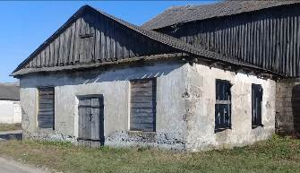 | 1827 | Butter churn br.2 (Ivanovo) | 12/01/1967 |  | - | -
 | 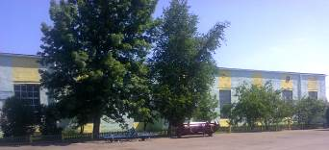 | 0112 | Workshop br1  (ag. Snitovo, No. 132/754-6783 dated 14.09.2010) | 12/31/1975 |  | 822.0 | -
 | 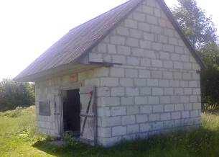 | 0012 | Mill br.1  (ag. Snitovo) | 01/01/1957 |  | 108.0 | -
 | 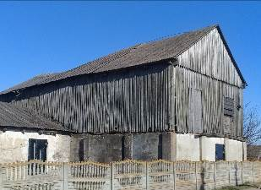 | 28 | Mill br.2 (Ivanovo) | 01/01/1960 |  | 180.0 | -
 | 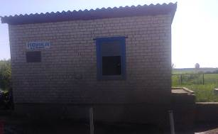 | 3843 | Washing of agricultural machines br.1  (ag. Snitovo) | 03/30/2012 |  | - | -
 | 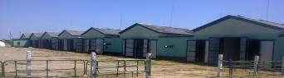 | 0128a | Monoblock 8 rooms  (ag. Snitovo, No. 132/754-4210 dated 06/10/2009) | 08/01/1980 |  | 11268.6 | -
 | 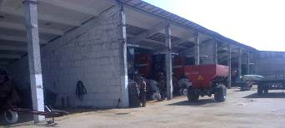 | 5321 | Canopy for combines br.1  (ag. Snitovo) | 12/31/1985 |  | 825.0 | -
 |  | 0143 |  |  |  | 1216.1 | -
 | 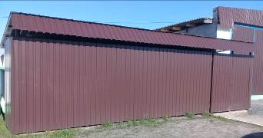 | 630 | Shed for bicycles (Ivanovo, Barskogo st., 10B) | 07/01/1997 |  | 22.0 | -
 | 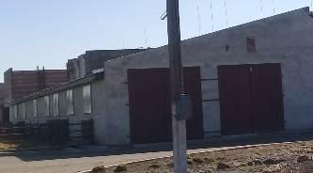 | 4049 | Shed for calves | 31.12.2016 |  | - | -
 | 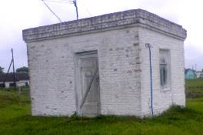 | 643 | Pumping station above an art well  (Ivanovo, Barskogo st., 10B) | 07/01/1965 |  | - | -
 | 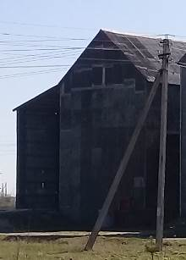 | 4029 | OBV (ag. Snitovo) | 12/31/2015 |  | - | -
 | 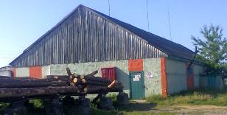 | 3326 | Sawmill br.1  (ag. Snitovo) | 12/31/1996 |  | 2520.0 | -
 | 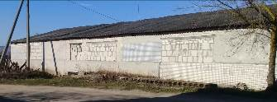 | 3063 | Sawmill br.2 (Ivanovo) | 12/31/1992 |  | - | -
 | 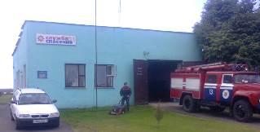 | 0126 | Fire post br.1  (ag. Snitovo) | 03/31/1980 |  | - | -
 | 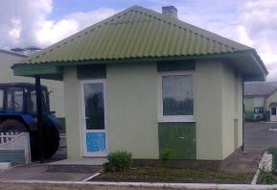 | 4023 | Checkpoint (Ivanovo) | 03/01/2012 |  | - | -
 | 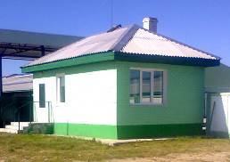 | 4003 | Checkpoint (pos. 7) (v. Vorotsevichi) | 08/06/2015 |  | 25.1 | -
 | 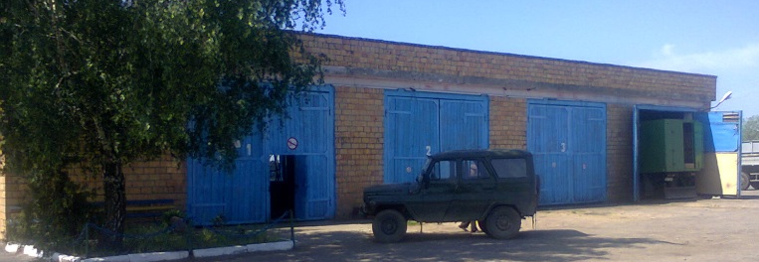 | 2108 | Maintenance point br.1  (ag. Snitovo) | 12/30/1985 |  | - | -
 | 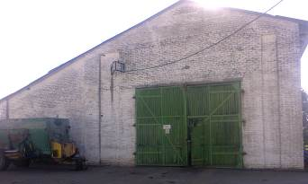 | 0121 | Repair shop br.3  (v. Vorotsevichi, No. 132/1394-35 dated 14.08.2012) | 01/01/1973 |  | 570.7 | -
 | 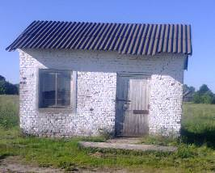 | 0018 | Shed under DKU (mill) br.3  (v. Vorotsevichi) | 01/01/1959 |  | - | -
 | 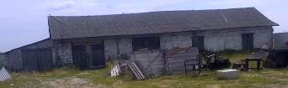 | 0060 | Warehouse of spare parts br.3  (v. Vorotsevichi) | 01/01/1973 |  | - | -
 | 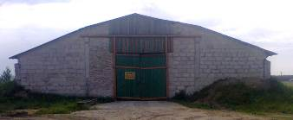 | 0139 | Warehouse for mineral fertilizers  (ag. Snitovo) | 12/31/1982 |  | 1296.0 | -
 | 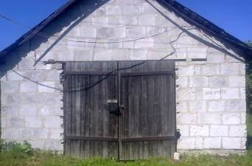 | 0058 | Warehouse in the garden br.3 (v. Vorotsevichi) | 12/01/1976 |  | - | -
 | 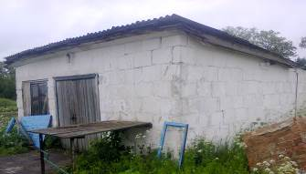 | 633 | Warehouse of fuels and lubricants No. 15 center. (Stable)  (Ivanovo, Barskogo st., 10B, No. 74 dated 06.06.2001) | 07/01/1962 |  | 4.7 | -
 | 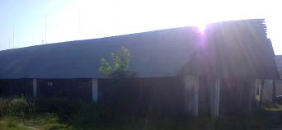 | 0053 | Warehouse of spare parts br.1 (ag. Snitovo) | 01/01/1964 |  | 767.0 | -
 | 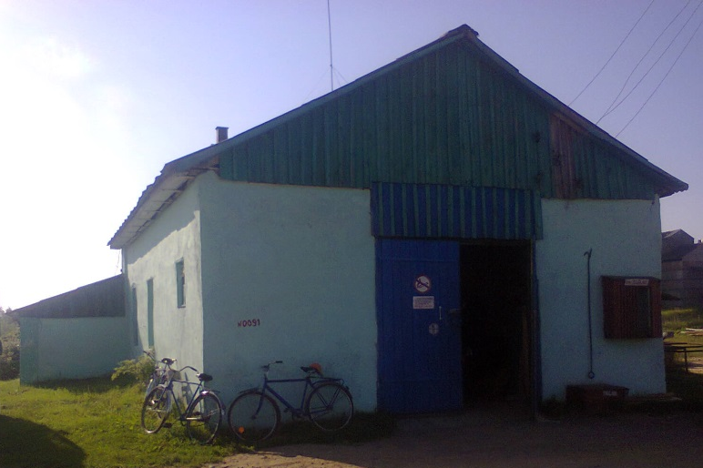 | 0091 | Warehouse of building materials br.1  (ag. Snitovo) | 12/01/1971 |  | 96.0 | -
 | 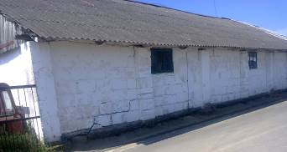 | 0082 | Warehouse for electrical goods br.1  (ag. Snitovo) | 12/01/1970 |  | 14.0 | -
 | 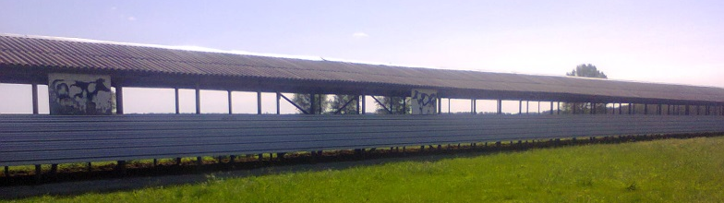 | 3688 | Cattle drive with a canopy br. 1 (ag. Snitovo) | 06/30/2008 |  | 294.0 | - | -
 | 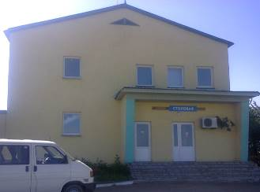 | 0124 | Canteen (livestock house)  (ag. Snitovo, No. 132/1394-36 dated 14.08.2012) | 12/31/1979 |  | 276.3 | -
 | 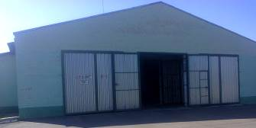 | 0127 | Calf house of the 1st period | 03/31/1980 |  | 2481.7 | -
 | 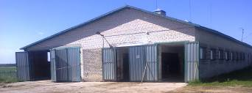 | 0123 | Calf house 2 periods | 12/30/1979 |  | 878.8 | -
 | 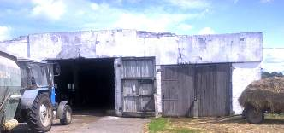 | 3061 | Calf house br.2 (Ivanovo) | 12/31/1993 |  | 750.0 | -
 | 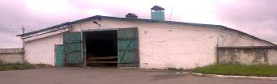 | 19 | Calf br.2  (Ivanovo, Komsomolskaya st.) | 12/01/1970 |  | 1249.0 | -
 | 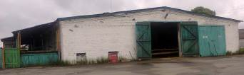 | 20 | Calf br.2  (Ivanovo, Komsomolskaya st.) | 12/01/1974 |  | 1265.0
 | 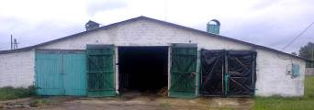 | 25 | Calf br.2  (Ivanovo, Komsomolskaya st.) | 12/01/1975 |  | 757.0 | -
 | 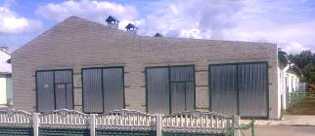 | 4017 | Calf house br.2 (Ivanovo) | 03/01/2012 |  | - | -
 | 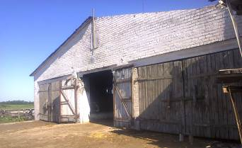 | 0115 | Calf barn for 117 heads br.3  (v. Vorotsevichi) | 12/31/1977 |  | 1402.5 | - | Reconstruction of a calf barn for 117 heads
 | 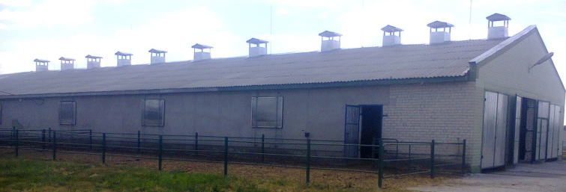  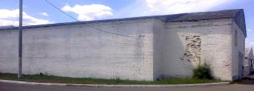  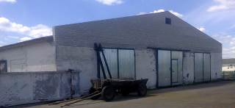 | 0025 | Calf houses, maternity ward, warehouse for storing onions br.3  (v. Vorotsevichi) | 12/01/1974 |  | 2269.0 | - | The current repair of the calf house is being carried out
 | 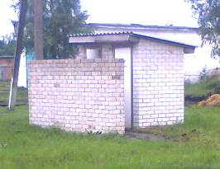 | 652 | Toilet | 06/01/2001 |  | - | -
 | 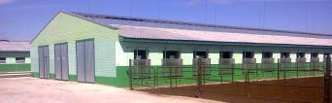 | 0074 | Workshop of dry cows 1 period br.3  (v. Vorotsevichi, No. 132/1431-6614 dated 08/15/2015) | 01/01/1969 |  | 1645.0 | - | Reconstruction of the barn for the dry cows shop of the 1st period
 | 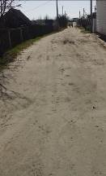 | 2694a | Asphalt road on ag. Snitovo (access road to the complex br. 1 (2 km)) | 12/31/1980 |  | - | -
 | 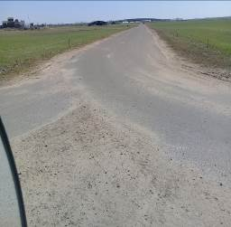 | 2969 | Asphalt roads 6.2 km (Snitovo 3.4 km, Vorotsevichi 2.8 km) | 12/31/1981 |  | - | -
 | 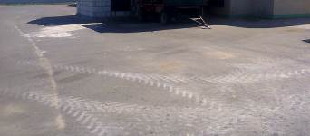 | 3844 | Asphalt roads f.1  (ag. Snitovo) | 03/01/2012 |  | - | -
 | 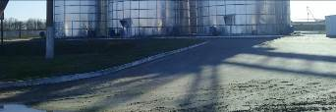 | 627 | Asphalt concrete pavement PPR Mogilno  (Ivanovo, Komsomolskaya street) | 07/01/1992 |  | - | -
 | 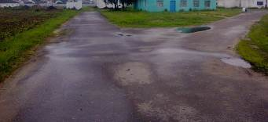 | 645 | Asphalt concrete coating PPR center.  (Ivanovo, Barskogo st., 10B) | 07/01/1987 |  | - | -
 | 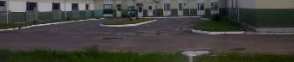 | 4025 | Asphalt concrete pavement f.2  (Ivanovo) | 03/01/2012 |  | - | -
 | 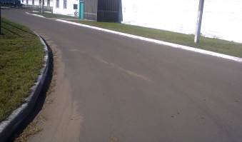 | 3894 | Landscaping f.3 (asphalt)  (v. Vorotsevichi) | 31.12.2012 |  | - | -
 | 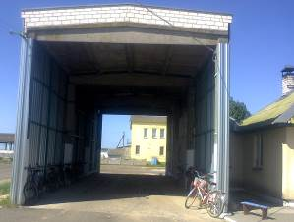 | 2692 | Weight with 30-ton scales br.1  (ag. Snitovo) | 12/31/1989 |  | - | -
 | 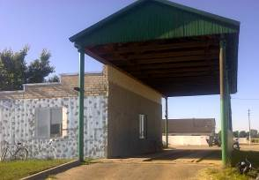 | 2697 | Weight with 30-ton scales br.3  (v. Vorotsevichi) | 12/31/1989 |  | - | - | Current repair in progress
 | 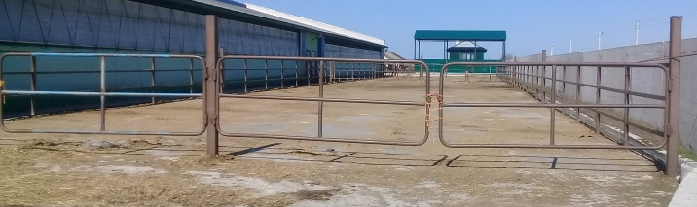 | 4008 | Walking area (pos. 9.1)  (v. Vorotsevichi) | 08/06/2015 |  | - | -
 | 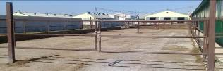 | 4009 | Walking area (pos. 9.2)  (v. Vorotsevichi) | 08/06/2015 |  | - | -
 | 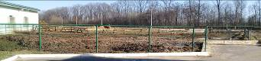 | 4019 | Walking area for cows f.2  (Ivanovo) | 03/01/2012 |  | - | -
 | 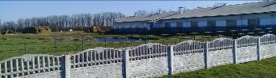 | 4027 | Walking area for cows f.2  (Ivanovo) | 03/01/2012 |  | - | -
 | 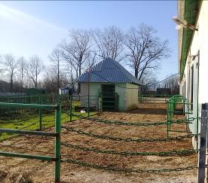 | 4018 | Walking area for calves f.2  (Ivanovo) | 03/01/2012 |  | - | -
 | 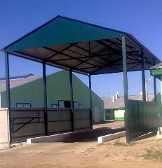 | 4004 | Dezbarrier with a canopy (pos. 8)  (v. Vorotsevichi) | 08/06/2015 |  | 108.0 | -
 | 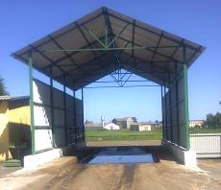 | 3859 | Dezbarrier f.1  (ag. Snitovo) | 05/31/2012 |  | - | -
 | 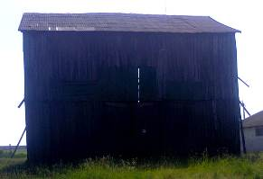 | 0114 | Building of ventilated bunkers br.1 (ag. Snitovo) | 12/31/1977 |  | 121.0 | -
 | 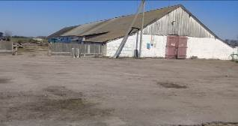 | 0604 | Grain area br.3  (v. Vorotsevichi) | 12/01/1975 |  | - | -
 | 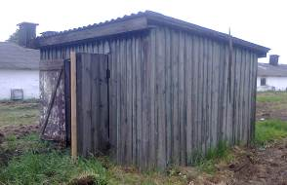 | 624 | SPS №1 Molodogvardeyskoe  (Ivanovo, Komsomolskaya st.) | 07/01/1986 |  | - | -
 | 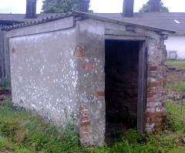 | 625 | KNS №2  (Ivanovo, Komsomolskaya st.) | 07/01/1993 |  | - | -
 |  | 4051 | Feed line | 31.12.2016 |  | - | -
 | 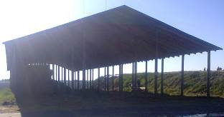 | 3975-7 | Canopy for hay f.3  (v. Vorotsevichi) | 21.10.2014 |  | - | -
 | 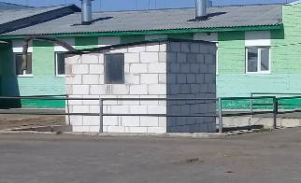 | 4007 | Manure collector capacity 100m3 (pos.6)  (v. Vorotsevichi) | 08/06/2015 |  | - | -
 |  | 64 | Pump station with art well | 12/01/1978 |  | - | -
 | 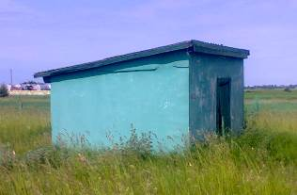 | 0652 | Pumping station br.1  (ag. Snitovo) | 12/01/1971 |  | 8 | -
 | 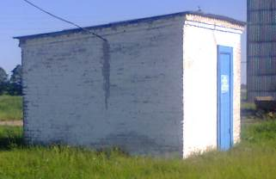 | 0093a | Pumping station br.3  (v. Vorotsevichi) | 12/01/1971 |  | - | -
 | 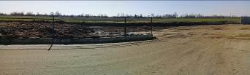 | 4005 | Site for temporary storage of manure (item 4.1)  (v. Vorotsevichi) | 08/06/2015 |  | - | -
 | 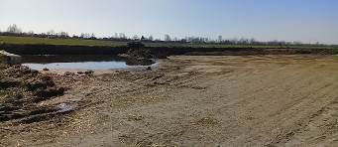 | 4006 | Site for temporary storage of manure (item 4.2)  (v. Vorotsevichi) | 08/06/2015 |  | - | -
 | 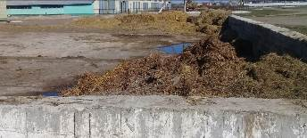 | 3666 | Site for temporary storage of manure br.1 (ag. Snitovo) | 12/01/2007 |  | 180.0 | -
 | 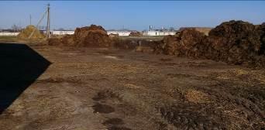 | 4020 | Site for loading manure f.2  (Ivanovo) | 03/01/2012 |  | - | -
 | 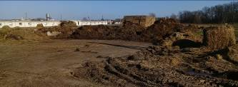 | 4022 | Site for loading manure f.2  (Ivanovo) | 03/01/2012 |  | - | -
 | 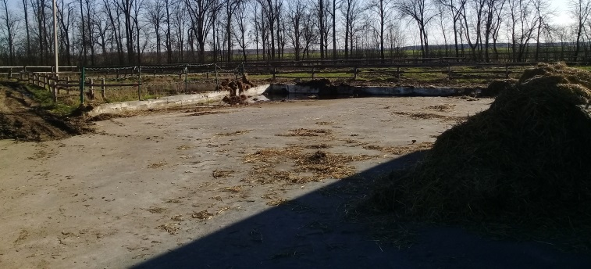 | 4021 | Site for loading manure f.2  (Ivanovo) | 03/01/2012 |  | - | -
 | 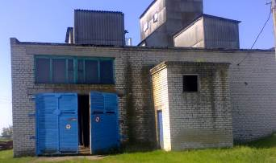 | 2696 | Seed-cleaning line br.1  (ag. Snitovo) | 12/31/1989 |  | - | -
 | 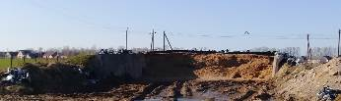 | 4050 | Silage trench for 1500 tons  (Ivanovo, Komsomolskaya st.) | 31.12.2016 |  | 576.0 | -
 | 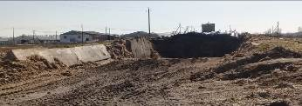 | 0837 | Hay pit br.3  (v. Vorotsevichi) | 12/01/1983 |  | - | -
 | 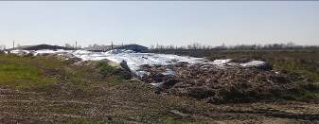 | 0817 | Hay pit br.3  (v. Vorotsevichi) | 12/31/1979 |  | - | -
 | 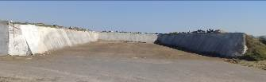 | 3668 | Hay pit br.3  (v. Vorotsevichi) | 12/01/2007 |  | - | -
 | 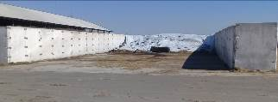 | 3975-6 | Silo (haylage) trench f.3  (v. Vorotsevichi) | 21.10.2014 |  | - | -
 | 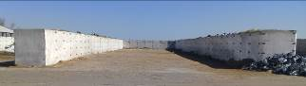 | 3975-5 | Silo (haylage) trench f.3  (v. Vorotsevichi) | 21.10.2014 |  | - | -
 | 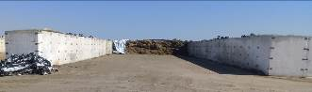 | 3975-4 | Silo (haylage) trench f.3  (v. Vorotsevichi) | 21.10.2014 |  | - | -
 | 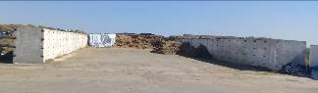 | 4001 | Trench for silage (haylage) (pos. 27)  (v. Vorotsevichi) | 08/06/2015 |  | 840.0 | -
 | 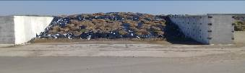 | 4002 | Trench for silage (haylage) (pos. 28) | 08/06/2015 |  | 840.0 | -
 |  | 0140 | Cowshed for keeping dry cows and maternity ward at MTF br.2 | 12/29/2017 |  | 1640
 |  | 4273 | Cowshed up to 300 dairy cows | 09.08.2021 |  | 1870
 | 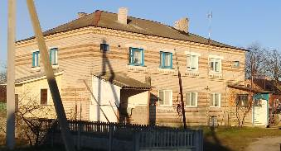 | 0075a | 1 sq. in 4 sq. residential building (Ivanovo, Shevchenko st., 8, No. 132/1431-1736 of 06/17/2013) | 12/01/1969 |  | 68.7 | -
 | 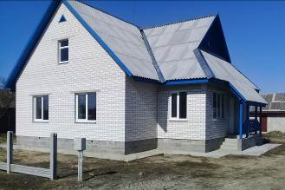 | 4031 | Single-family residential building  (ag. Snitovo, Komsomolskaya st., 30) | 12/28/2015 |  | 73.23 | -
 | 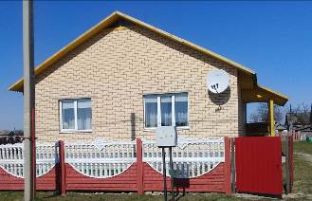 | 3958 | Single-family residential building  (ag. Snitovo, Novaya st., 2d, No. 132/1431-3528 dated 06/04/2014) | 03/31/2014 |  | 80.1 | -
 | 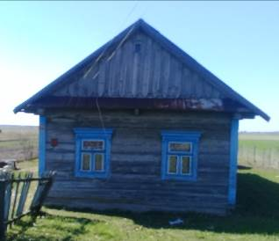 | 3317 | One-apartment residential building (ag. Snitovo, Zheleznodorozhnaya st., 30) | 04/30/1996 |  |  | -
 | 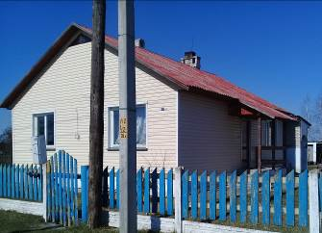 | 3744 | Single-apartment residential building (town of Snitovo, Komsomolskaya st., 38a, No. 132/754-5721 dated 05/11/2010) | 03/30/2010 |  | 70.9 | -
 | 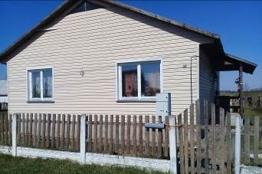 | 3732 | Single-apartment residential building (town of Snitovo, Komsomolskaya st., 38b, No. 132/754-4829 dated 10/15/2009) | 06/30/2009 |  | 69.8 | -
 | 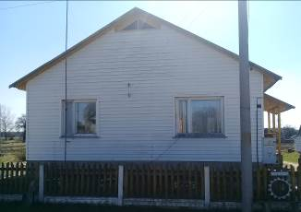 | 3648 | Single-apartment residential building (town of Snitovo, Leninskaya st., 33, No. 132/754-6526 of 08/06/2010) | 06/30/2007 |  | 70.0 | -
 | 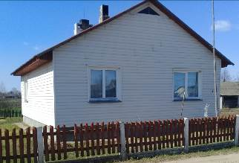 | 3686 | Single-apartment residential building (town of Snitovo, Leninskaya st., 57b, 132/754-3095 dated 10/11/2008) | 06/27/2008 |  | 72.6 | -
 | 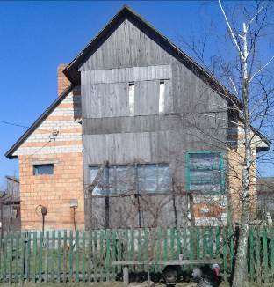 | 153 | One-apartment residential building (ag. Snitovo, Novaya st., 10) | 06/01/1985 |  | - | -
 | 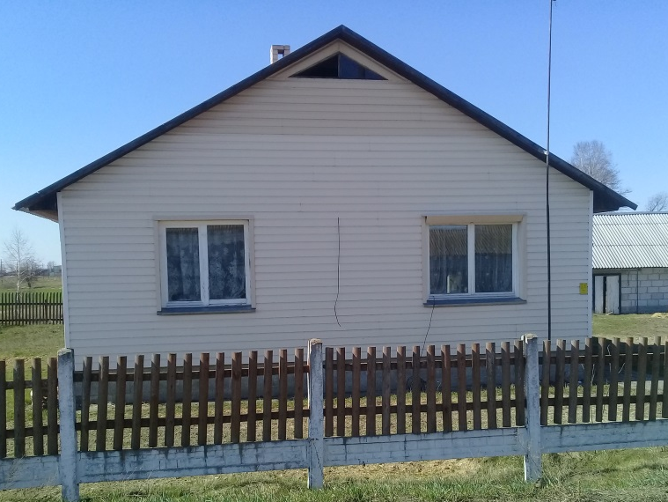 | 3715 | Single-apartment residential building (town of Snitovo, Novaya st., 26, No. 132/754-4146 dated May 27, 2009) | 03/31/2009 |  | 71.2 | -
 | 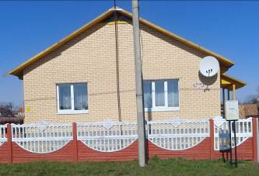 | 3922 | Single-apartment residential building (city of Snitovo, Novaya st., 2v, No. 132/1431-2849 of 01/27/2014) | 06/28/2013 |  | 80.2 | -
 | 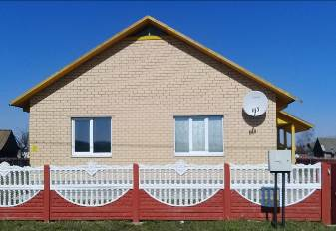 | 3932 | Single-family residential building (town of Snitovo, Novaya st., 2g, No. 132/1431-2850 of 01/27/2014) | 09/30/2013 |  | 79.9 | -
 | 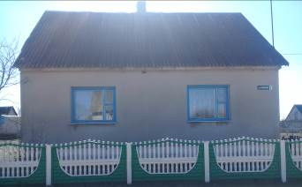 | 3375 | Single-apartment residential building (town of Snitovo, Polevaya st., 1, No. 132/754-9028 dated 11/24/2011) | 12/31/1999 |  | 90.1 | -
 | 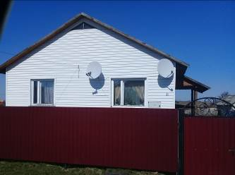 | 3675 | Single-apartment residential building (town of Snitovo, Polevaya st., 2b, No. 132/754-3098 dated 10/11/2008) | 03/31/2008 |  | 70.9 | -
 | 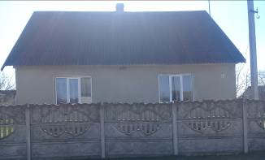 | 3365 | Single-apartment residential building (town of Snitovo, Polevaya st., 5, No. 132/754-9032 dated 11/24/2011) | 07/01/1998 |  | 88.7 | -
 | 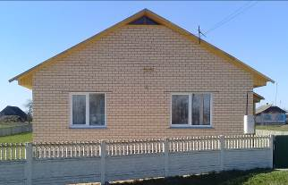 | 3799 | Single-apartment residential building (town of Snitovo, Sovetskaya st., 7a, No. 132/754-8831 dated 09/14/2011) | 04/29/2011 |  | 82.4 | -
 | 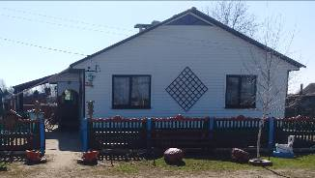 | 3590 | Single-apartment residential building (village of Vorotsevichi, Krupskoy st. | 06/01/2005 |  | 75.9 | -
 | 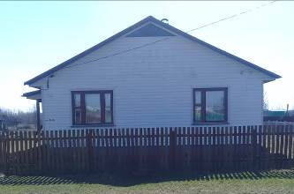 | 3606 | Single-apartment residential building (village of Vorotsevichi, Krupskoy st. | 11/30/2005 |  | 75.7 | -
 | 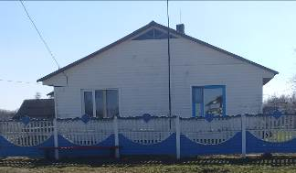 | 3591 | Single-apartment residential building (village of Vorotsevichi, Krupskoy st., 106, No. 132/754-3213 of November 12, 2008) | 06/01/2005 |  | 75.4 | -
 | 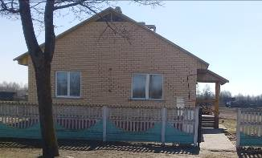 | 3758 | Single-apartment residential building (v. Vorotsevichi, Krupskoy st., 112, No. 132/754-7581 of 01.28.2011) | 07/31/2010 |  | 82.0 | -
 | 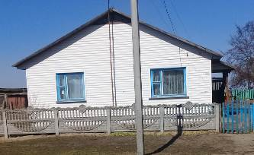 | 3593 | Single-apartment residential building (village of Vorotsevichi, Krupskoy st. | 06/01/2005 |  | 76.7 | -
 | 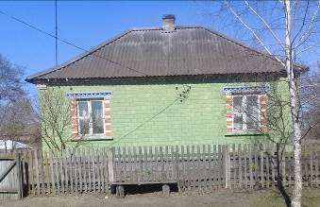 | 3477 | Single-apartment residential building (village of Vorotsevichi, Krupskoy st. | 12/18/2002 |  | 53.1 | -
 | 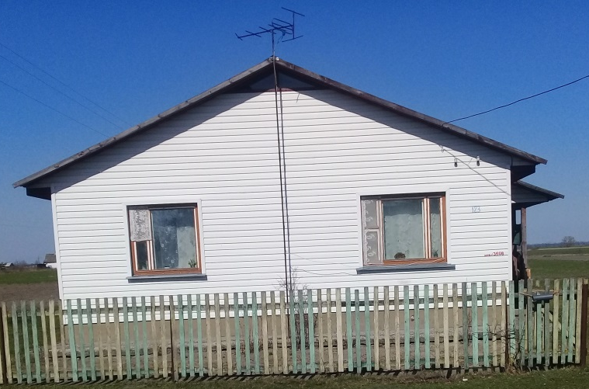 | 3608 | Single-apartment residential building (village of Vorotsevichi, Krupskoy st. | 11/30/2005 |  | 73.5 | -
 | 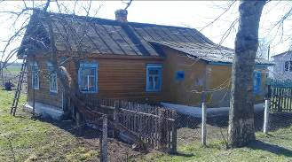 | 2997 | One-apartment residential building (v. Vorotsevichi, Krupskoy st., 30) | 03/31/1992 |  | - | -
 | 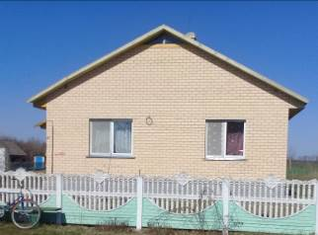 | 3766 | Single-apartment residential building (village of Vorotsevichi, Krupskoy st., 47, No. 132/754-7579 of 01/28/2011) | 09/30/2010 |  | 81.1 | -
 | 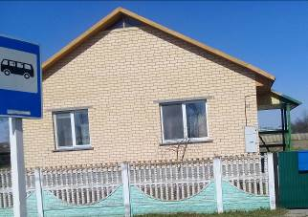 | 3754 | Single-apartment residential building (village of Vorotsevichi, Krupskoy st., 97a, No. 132/754-7580 of 01/28/2011) | 06/30/2010 |  | 81.4 | -
 | 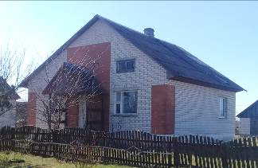 | 3515 | Single-apartment residential building (village of Vorotsevichi, Sadovaya st., 9, No. 132/754-7017 dated 09/30/2010) | 12/01/2003 |  | 85.3 | -

IX. Information about machines and equipment:

Inventory . number | Name | Number of  units | Purpose  (place in the technological process) | Year  of Entry | Condition  (% wear)
4195 | Subscriber terminal SMART | 1 | Performing agricultural work | 04/14/2020 | 66.69
4229 | HP without water heating Kranzle 2175TS | 1 | Performing agricultural work | 06.11.2020 | 41.67
4083 | Bus PAZ 32053 used state number 55-91 AA-1 | 1 | Performing agricultural work | 01/17/2018 | 100.00
594 | auto scales | 1 | Performing agricultural work | 01/01/1993 | 100.00
3614 | Car GAZ-31105-120 "Volga" No. 59-63 AN-1 | 1 | Performing agricultural work | 04.01.2006 | 100.00
3838 | Car "Skoda Superb Ambition" №72-11 IK | 1 | Performing agricultural work | 28.02.2012 | 100.00
4259 | Used car GAZ 3309 KUPAVA 473800 | 1 | Performing agricultural work | 04/14/2021 | 27.78
4227 | Car LADA (Niva) 21310 46-44 ME-1 | 1 | Performing agricultural work | 09/01/2020 | 33.33
3871 | Car LADA 21214-121-40vin №2033 II-1 | 1 | Performing agricultural work | 07/31/2012 | 100.00
3923 | Car LADA 21214-121-40vin №8742 IM-1 | 1 | Performing agricultural work | 07/04/2013 | 100.00
4318 | Automobile used Volkswagen Transporter  65 - 98 MT -1 | 1 | Performing agricultural work | 11/21/2022 | 4.17
4261 | Truck dump truck MAZ 650108 AI 8553-1 | 1 | Performing agricultural work | 06/30/2021 | 21.43
4247 | Truck special feeder KAMAZ 5320 used AN 6342-1 | 1 | Performing agricultural work | 02/01/2021 | 23.96
4086 | Car KAMAZ 5320 g/p 8t AN 42 69-1 | 1 | Performing agricultural work | 06/08/2018 | 100.00
4319 | Car MAZ 551605-225 BU | 1 | Performing agricultural work | 11/30/2022 | 1.04
3534 | Car UAZ 31519-095 No. 06-43 AV-1 | 1 | Performing agricultural work | 08/19/2004 | 100.00
4201 | Vehicle UAZ 3163 state number 16-01 ME-1 | 1 | Performing agricultural work | 06/25/2020 | 31.25
3715a | Car trailer for MAZ №A7642А-1 | 1 | Performing agricultural work | 04/08/2009 | 100.00
3633 | Car trailer MAZ 856100-024 No. A2212 E-1 | 1 | Performing agricultural work | 08/08/2006 | 100.00
3757 | Car trailer MAZ-856100-4016 No. 55-97 AA-1 | 1 | Performing agricultural work | 07/09/2010 | 100.00
2206 | Autodrinker VUK-3 | 1 | Performing agricultural work | 06/01/1988 | 100.00
2719 | Autodrinker VUO-3 | 1 | Performing agricultural work | 02/28/1990 | 100.00
3464 | Unit AKSH-6.0 | 1 | Performing agricultural work | 08/30/2002 | 100.00
3433 | Unit AKSH-7.2 | 1 | Performing agricultural work | 09/01/2000 | 100.00
598 | APK-10 unit | 1 | Performing agricultural work | 01/01/1993 | 100.00
3832 | Unit APP-6 AB-8 " Berestie " ( grain seeder .) | 1 | Performing agricultural work | 30.12.2011 | 91.67
3503 | Combined tillage unit AKR-3 | 1 | Performing agricultural work | 29.10.2003 | 100.00
3887 | Heating unit AO-EVO, 3-24kW br . 2 | 1 | Performing agricultural work | 05.12.2012 | 40.84
4324 | Diamond drilling machine SCY-2050E | 1 | Performing agricultural work | 30.12.2022 | 100.00
3945 | Milk analyzer " Yokomilk " f.2 | 1 | Performing agricultural work | 12/31/2013 | 100.00
3946 | Milk analyzer " Yokomilk " f.3 | 1 | Performing agricultural work | 12/31/2013 | 100.00
4173 | Milk analyzer EKOMILK-120. MILKANA KAM-98-2A (9 pairs) | 1 | Performing agricultural work | 30.10.2019 | 63.34
4174 | Milk analyzer EKOMILK-120. MILKANA KAM-98-2A (9 pairs) | 1 | Performing agricultural work | 30.10.2019 | 63.34
3665 | High pressure apparatus | 1 | Performing agricultural work | 12/17/2007 | 100.00
5396 | Milk tank 200l | 1 | Performing agricultural work | 05/01/1987 | 100.00
3496 | Tank with stand f.1 | 1 | Performing agricultural work | 08/01/2003 | 87.37
2586 | Milk tanks | 1 | Performing agricultural work | 12/31/1988 | 100.00
3889 | Gasoline generator AB 5.8-T230-1V | 1 | Performing agricultural work | 12/14/2012 | 100.00
3866 | Gasoline generator AB-8-T 400-1V | 1 | Performing agricultural work | 06/12/2012 | 100.00
4053 | Concrete mixer SM-160C | 1 | Performing agricultural work | 03/31/2017 | 71.87
3990 | BS-700 concrete mixer | 1 | Performing agricultural work | 05/21/2015 | 75.00
3348a | Harrow (pasture) KCh-5.1 | 1 | Performing agricultural work | 04/30/1998 | 100.00
3487 | Harrow AB-9M | 1 | Performing agricultural work | 04/14/2003 | 100.00
4303 | Heavy disc harrow BDT-7.0 | 1 | Performing agricultural work | 04/21/2022 | 11.11
4092 | Heavy disc harrow L-114A-02 | 1 | Performing agricultural work | 08/03/2018 | 72.22
503 | Bunker | 1 | Performing agricultural work | 07/01/1984 | 100.00
504 | Bunker | 1 | Performing agricultural work | 07/01/1984 | 100.00
505 | Bunker | 1 | Performing agricultural work | 07/01/1984 | 100.00
3978 | Dry feed bunker BSK-9 | 1 | Performing agricultural work | 25.02.2015 | 75.00
4034 | Hopper mixer | 1 | Performing agricultural work | 29.02.2016 | 75.00
3615 | Drill garden BS-500 | 1 | Performing agricultural work | 20.12.2005 | 100.00
2976 | Burtoukryvshchik BN-100A | 1 | Performing agricultural work | 01/31/1992 | 100.00
3781 | Refrigerated car | 1 | Performing agricultural work | 12/20/2010 | 100.00
3626 | Vacuum unit PVU-70-2 class 3 | 1 | Performing agricultural work | 06/21/2006 | 100.00
3625 | Vacuum unit PVU-70-2 f.3 | 1 | Performing agricultural work | 06/21/2006 | 100.00
4199 | Windrower 7 Limer 1250 | 1 | Performing agricultural work | 06/08/2020 | 31.25
7628 | Weights | 1 | Performing agricultural work | 12/30/1982 | 100.00
586 | Weights GP-15 | 1 | Performing agricultural work | 11/01/1991 | 100.00
3792a | Weights RP-15Sh13f.1 | 1 | Performing agricultural work | 03/21/2011 | 100.00
2158 | Weights CH-500 | 1 | Performing agricultural work | 03/09/1988 | 100.00
2603a | 40-ton scales at KZS | 1 | Performing agricultural work | 06/30/1989 | 100.00
4062 | Scales MK-15.2 TN21 electronic trading | 1 | Performing agricultural work | 09/12/2017 | 65.75
3747 | Scales RP-1Sh 13 M | 1 | Performing agricultural work | 12/31/1976 | 100.00
3746 | Scales RP-1Sh13m | 1 | Performing agricultural work | 12/31/1976 | 100.00
3773 | Electronic scales for weighing livestock | 1 | Performing agricultural work | 11/25/2010 | 100.00
3879 | Electronic scales for weighing livestock | 1 | Performing agricultural work | 10.10.2012 | 100.00
3635 | Scales electronic PPR | 1 | Performing agricultural work | 10/31/2006 | 100.00
4312 | Electronic milk viscometer Expert Somatos-1 | 1 | Performing agricultural work | 07/15/2022 | 8.33
4251 | showcase "VILIA" | 1 | Performing agricultural work | 24.02.2021 | 18.33
4230 | Refrigerated showcase "Dvina-150" used | 1 | Performing agricultural work | 11/30/2020 | 20.86
4231 | Refrigerated showcase "Dvina-150" used | 1 | Performing agricultural work | 11/30/2020 | 20.86
4232 | Refrigerated showcase "Dvina-150" used | 1 | Performing agricultural work | 11/30/2020 | 20.86
3831 | Refrigerated showcase (mag) | 1 | Performing agricultural work | 12/01/2011 | 91.65
4311 | Grain moisture meter "Fauna-M" | 1 | Performing agricultural work | 07/01/2022 | 10.00
540 | Vodorazd . to heat generators | 1 | Performing agricultural work | 09/01/1987 | 100.00
2658 | Water dispenser VU-3 | 1 | Performing agricultural work | 10/30/1989 | 100.00
2659 | Water dispenser VU-3 | 1 | Performing agricultural work | 10/30/1989 | 100.00
2903 | Water dispenser VU-3 | 1 | Performing agricultural work | 03/30/1991 | 100.00
3783 | Air cooler for refrigeration unit | 1 | Performing agricultural work | 12/30/2010 | 100.00
3986 | Foam generator, wall-mounted device for manual spraying FI-WC 1148ST ( imp .) | 1 | Performing agricultural work | 04/30/2015 | 60.00
3987 | Foam generator, wall-mounted device for manual spraying FI-WC 1148ST ( imp .) | 1 | Performing agricultural work | 04/30/2015 | 60.00
3991 | Foam generator, wall-mounted device for manual spraying FI-WC 1148ST ( imp .) | 1 | Performing agricultural work | 06/10/2015 | 60.01
3992 | Foam generator, wall-mounted device for manual spraying FI-WC 1148ST ( imp .) | 1 | Performing agricultural work | 06/10/2015 | 60.01
3728 | VGR-7 rake, swath former, | 1 | Performing agricultural work | 05/28/2009 | 100.00
4310 | Rake wheel-finger GRL-9,6-01 | 1 | Performing agricultural work | 06/21/2022 | 6.25
3854 | Rake, swath former GA 6002//1141110 | 1 | Performing agricultural work | 05/31/2012 | 87.50
3681 | Rake, tedder VRP-8.3 | 1 | Performing agricultural work | 06/02/2008 | 100.00
356 | Truck (GAZ-53B) No. AE 94-07-1 ( Egg carrier ) | 1 | Performing agricultural work | 10/01/1987 | 100.00
3011 | Truck GAZ 3507 (GAZ-53 SAZ) No. AM 31-96-1 | 1 | Performing agricultural work | 08/30/1992 | 100.00
3013 | Truck GAZ 3507 (GAZ-53 SAZ) No. AM 3124-1 | 1 | Performing agricultural work | 08/30/1992 | 100.00
5276 | Truck GAZ 3507 (Dump truck GAZ-53) SAZ No. AM 3054-1 | 1 | Performing agricultural work | 07/26/1986 | 100.00
3811 | Used truck GAZ-3302 10 № AI 3371-1 | 1 | Performing agricultural work | 08.08.2011 | 100.00
3751 | Truck GAZ-3309 No. AE 1424-1 | 1 | Performing agricultural work | 05/21/2010 | 100.00
3014 | Truck GAZ-3507 No. AM 50-60-1 | 1 | Performing agricultural work | 08/30/1992 | 100.00
2660 | Truck GAZ-352-01 No. 60-59-1 | 1 | Performing agricultural work | 10/30/1989 | 100.00
340 | Truck GAZ5204 "DUK" No. AC 69-49 | 1 | Performing agricultural work | 04/01/1983 | 100.00
6411 | Truck GAZ-53A No. AM 3138-1 | 1 | Performing agricultural work | 07/31/1977 | 100.00
3778 | Used truck IZH-2717230 No. AE 9882-1 | 1 | Performing agricultural work | 09.12.2010 | 100.00
3478 | Truck KAMAZ-55102 No. AM 3055-1 | 1 | Performing agricultural work | 12/31/2002 | 100.00
3756 | Truck MAZ-551605 No. AE 2871-1 | 1 | Performing agricultural work | 07/09/2010 | 100.00
3632 | Truck MAZ-551605-225 № AK 7484-1 | 1 | Performing agricultural work | 08/08/2006 | 100.00
3538 | Truck MAZ-555102 No. AM 2517-1 | 1 | Performing agricultural work | 09/10/2004 | 100.00
3714a | Truck MAZ-555142 No. 56-95 AB-1 | 1 | Performing agricultural work | 04/08/2009 | 100.00
4654 | Truck UAZ-452D No. IM 74-20-1 | 1 | Performing agricultural work | 12/31/1980 | 100.00
3855 | Used Volkswagen LT35 truck No. AI 4142-1 | 1 | Performing agricultural work | 05/30/2012 | 100.00
3882 | Truck MAZ-437043-(335) No. AI 3744-1 | 1 | Performing agricultural work | 11/30/2012 | 100.00
360 | Cargo vehicle ZIL 431412 (ZSK-10) No. AC 71-05 | 1 | Performing agricultural work | 06/01/1989 | 100.00
3927 | Group house for calves | 1 | Performing agricultural work | 08/14/2013 | 89.57
3928 | Group house for calves | 1 | Performing agricultural work | 08/14/2013 | 89.57
4196 | Fuel level sensor 1000mm | 1 | Performing agricultural work | 04/14/2020 | 66.69
4214 | Fuel level sensor 1000mm | 1 | Performing agricultural work | 07/02/2020 | 60.47
4215 | Fuel level sensor 1000mm | 1 | Performing agricultural work | 07/02/2020 | 60.47
4216 | Fuel level sensor 1000mm | 1 | Performing agricultural work | 07/02/2020 | 60.47
4217 | Fuel level sensor 1000mm | 1 | Performing agricultural work | 07/02/2020 | 60.47
4218 | Fuel level sensor 1000mm | 1 | Performing agricultural work | 07/02/2020 | 60.47
4114 | Fuel level sensor LLS 1000mm | 1 | Performing agricultural work | 08/15/2018 | 100.00
4115 | Fuel level sensor LLS 1000mm | 1 | Performing agricultural work | 08/15/2018 | 100.00
4123 | Fuel level sensor LLS 1000mm | 1 | Performing agricultural work | 08/17/2018 | 100.00
4129 | Fuel level sensor LLS 1000mm | 1 | Performing agricultural work | 09/01/2018 | 100.00
4107 | Fuel level sensor LLS 700mm | 1 | Performing agricultural work | 08/15/2018 | 100.00
4108 | Fuel level sensor LLS 700mm | 1 | Performing agricultural work | 08/15/2018 | 100.00
4109 | Fuel level sensor LLS 700mm | 1 | Performing agricultural work | 08/15/2018 | 100.00
4110 | Fuel level sensor LLS 700mm | 1 | Performing agricultural work | 08/15/2018 | 100.00
4111 | Fuel level sensor LLS 700mm | 1 | Performing agricultural work | 08/15/2018 | 100.00
4112 | Fuel level sensor LLS 700mm | 1 | Performing agricultural work | 08/15/2018 | 100.00
4113 | Fuel level sensor LLS 700mm | 1 | Performing agricultural work | 08/15/2018 | 100.00
4119 | Fuel level sensor LLS 700mm | 1 | Performing agricultural work | 08/17/2018 | 100.00
4120 | Fuel level sensor LLS 700mm | 1 | Performing agricultural work | 08/17/2018 | 100.00
4121 | Fuel level sensor LLS 700mm | 1 | Performing agricultural work | 08/17/2018 | 100.00
4122 | Fuel level sensor LLS 700mm | 1 | Performing agricultural work | 08/17/2018 | 100.00
4128 | Fuel level sensor LLS 700mm | 1 | Performing agricultural work | 09/01/2018 | 100.00
4132 | Fuel level sensor LLS 700mm | 1 | Performing agricultural work | 21.09.2018 | 100.00
4133 | Fuel level sensor LLS 700mm | 1 | Performing agricultural work | 21.09.2018 | 100.00
4140 | Fuel level sensor LLS 700mm | 1 | Performing agricultural work | 03.12.2018 | 99.94
4141 | Fuel level sensor LLS 700mm | 1 | Performing agricultural work | 03.12.2018 | 99.94
4142 | Fuel level sensor LLS 700mm | 1 | Performing agricultural work | 03.12.2018 | 99.94
4144 | Fuel level sensor LLS 700mm | 1 | Performing agricultural work | 03.12.2018 | 99.94
4147 | Fuel level sensor Omnicomm LLS 4 700mm | 1 | Performing agricultural work | 01/10/2019 | 97.92
4148 | Fuel level sensor Omnicomm LLS 4 700mm | 1 | Performing agricultural work | 01/10/2019 | 97.92
4151 | Fuel level sensor Omnicomm LLS 4 700mm | 1 | Performing agricultural work | 01/24/2019 | 97.92
4152 | Fuel level sensor Omnicomm LLS 4 700mm | 1 | Performing agricultural work | 01/24/2019 | 97.92
4156 | Fuel level sensor Omnicomm LLS 4 700mm | 1 | Performing agricultural work | 29.01.2019 | 97.92
4157 | Fuel level sensor Omnicomm LLS 4 700mm | 1 | Performing agricultural work | 29.01.2019 | 97.92
4158 | Fuel level sensor Omnicomm LLS 4 700mm | 1 | Performing agricultural work | 29.01.2019 | 97.92
4159 | Fuel level sensor Omnicomm LLS 4 700mm | 1 | Performing agricultural work | 29.01.2019 | 97.92
4160 | Fuel level sensor Omnicomm LLS 4 700mm | 1 | Performing agricultural work | 29.01.2019 | 97.92
4161 | Fuel level sensor Omnicomm LLS 4 700mm | 1 | Performing agricultural work | 29.01.2019 | 97.92
4225 | Fuel level sensor Omnicomm LLS 4 700mm | 1 | Performing agricultural work | 08/28/2020 | 58.38
4226 | Fuel level sensor Omnicomm LLS 4 700mm | 1 | Performing agricultural work | 08/28/2020 | 58.38
4208 | Diesel generator AD-240-T-400-2RP (DG-30) | 1 | Performing agricultural work | 07/31/2020 | 15.11
4079 | Diesel generator AD-240-T-400-2RP (DG-30) (from dismantling UDPM-8s KPDO-8) | 1 | Performing agricultural work | 12/28/2017 | 74.12
263 | Diesel Electric Generator | 1 | Performing agricultural work | 10/01/1981 | 100.00
569 | Diesel Electric Generator | 1 | Performing agricultural work | 01/01/1990 | 100.00
3736 | Milking machine UDP f.1 (frame) | 1 | Performing agricultural work | 08/31/2009 | 100.00
3737 | Milking machine UDP f.1 (frame) | 1 | Performing agricultural work | 08/31/2009 | 100.00
4207 | Milking machine UDPM- 8 | 1 | Performing agricultural work | 07/31/2020 | 24.17
3820 | Milking machine UDS (frame) f.3 | 1 | Performing agricultural work | 08/30/2011 | 95.27
3821 | Milking machine UDS (frame) f.3 | 1 | Performing agricultural work | 09/23/2011 | 95.26
3765 | Milking machine UDS (frame for 4 places) | 1 | Performing agricultural work | 09/29/2010 | 100.00
4325 | Milking equipment Parallel 1*10 BU | 1 | Performing agricultural work | 12/15/2022 | 100.00
3979 | house for heating | 1 | Performing agricultural work | 03/31/2015 | 74.94
4038 | Crusher H 96/42 | 1 | Performing agricultural work | 17.02.2016 | 75.00
4039 | Crusher H 96/42 | 1 | Performing agricultural work | 17.02.2016 | 75.00
3723 | Accumulation tank f.2 | 1 | Performing agricultural work | 02.05.2009 | 100.00
0062 | Capacity DB-0.6 | 1 | Performing agricultural work | 12/30/1987 | 100.00
3580 | Capacity DF-0.06 | 1 | Performing agricultural work | 05/20/2005 | 78.75
3581 | Capacity DF-0.06 | 1 | Performing agricultural work | 05/20/2005 | 78.75
3582 | Capacity DF-0.06 | 1 | Performing agricultural work | 06/21/2005 | 78.27
3583 | Capacity DF-0.06 | 1 | Performing agricultural work | 06/21/2005 | 78.27
3584 | Capacity DF-0.06 | 1 | Performing agricultural work | 06/21/2005 | 73.28
2608 | Capacity DF-0.6 | 1 | Performing agricultural work | 06/30/1989 | 100.00
3835 | Milk storage tank f.3 | 1 | Performing agricultural work | 22.02.2012 | 60.02
4178 | LCD monitor S24D332HSO SAMSUHG | 1 | Performing agricultural work | 11/15/2019 | 77.09
4249 | LCD monitor S24R356FHI SANSUNG | 1 | Performing agricultural work | 25.02.2021 | 36.67
3030 | Loader of dry feed (grain) automobile | 1 | Performing agricultural work | 10/30/1992 | 100.00
541 | Refueler for heat generators | 1 | Performing agricultural work | 09/01/1987 | 100.00
546a | Refueler for heat generators | 1 | Performing agricultural work | 01/01/1988 | 100.00
3587 | Grain cleaning machine MZS-20 (primary grain cleaning) | 1 | Performing agricultural work | 07/01/2005 | 100.00
2573a | Grain cleaning machine K 531 br.1 | 1 | Performing agricultural work | 12/31/1988 | 100.00
2728 | Grain cleaning machine K-531 Petkus giant | 1 | Performing agricultural work | 04/30/1990 | 100.00
2185 | Grain cleaning machine K-531/1 br.1 | 1 | Performing agricultural work | 05/01/1988 | 100.00
3603 | Grain cleaning machine MZS-20 (primary grain cleaning machine) | 1 | Performing agricultural work | 11/01/2005 | 100.00
3763b | Grain cleaning and drying equipment KZSV - 40GN _ | 1 | Performing agricultural work | 20.08.2010 | 100.00
3786 | Grain cleaning and drying equipment KZSV-40-G ( equipment of grain storage bins ) | 1 | Performing agricultural work | 29.12.2010 | 100.00
3630 | Combine harvester KZS-10 K "Polesie" AV1 4395 | 1 | Performing agricultural work | 07/21/2006 | 100.00
3650 | Combine harvester KZS-10 K "Polesie" AK1 0691 | 1 | Performing agricultural work | 07/07/2007 | 100.00
3926 | Combine harvester KZS-1218 AK1 4824 | 1 | Performing agricultural work | 08/01/2013 | 96.20
3727 | Combine harvester KZS-1218-10 "Polesie" AV1 3312 | 1 | Performing agricultural work | 05/12/2009 | 100.00
3872 | chopper IS-7.1 " Berestye " | 1 | Performing agricultural work | 08/21/2012 | 85.00
3691 | Chopper -distributor of straw and silage ALTOR6070 (KUHN) | 1 | Performing agricultural work | 07/11/2008 | 100.00
4043 | Chopper -mixer-distributor of fodder ISRK-12 "Hozyain" | 1 | Performing agricultural work | 05/23/2016 | 75.00
4065 | Chopper -mixer-distributor of fodder ISRK-12 "Hozyain" | 1 | Performing agricultural work | 11/14/2017 | 63.54
4081 | Frame of milking machine UDPM-8s (from dismantling of UDPM-8s KPDO-8) | 1 | Performing agricultural work | 12/28/2017 | 92.86
2655 | Potato planter KSM-4,1 | 1 | Performing agricultural work | 10/30/1989 | 100.00
3564 | Cash register " Minika " | 1 | Performing agricultural work | 10.02.2005 | 100.00
599 | Water-filled skating rink (3 pcs ) | 1 | Performing agricultural work | 01/01/1993 | 100.00
4087 | KKM " Minika 1102 MIK" | 1 | Performing agricultural work | 07/12/2018 | 100.00
4088 | KKM " Minika 1102 MIK" | 1 | Performing agricultural work | 07/12/2018 | 100.00
4089 | KKM " Minika 1102 MIK" | 1 | Performing agricultural work | 07/12/2018 | 100.00
4090 | KKM " Minika 1102 MIK" | 1 | Performing agricultural work | 07/12/2018 | 100.00
4091 | KKM " Minika 1102 MIK" | 1 | Performing agricultural work | 07/12/2018 | 100.00
3980 | Calf weighing cage | 1 | Performing agricultural work | 03/31/2015 | 60.08
3703 | Cage equipment for keeping laying hens for 36520 items. | 1 | Performing agricultural work | 30.10.2008 | 100.00
3768 | Ladle 320.45.01.000B No. 265 | 1 | Performing agricultural work | 11/30/2010 | 95.26
3949 | Bucket 527.57.00.000 universal with grapple | 1 | Performing agricultural work | 01/20/2014 | 88.54
3771 | Bucket 527.57.00.000 universal with grapple No. 024 | 1 | Performing agricultural work | 11/25/2010 | 95.27
3770 | Bucket 527.5700.000#147 Amkodor 527 | 1 | Performing agricultural work | 11/25/2010 | 95.25
3490 | Combined seed drill Amazonie | 1 | Performing agricultural work | 05/16/2003 | 100.00
3720 | Compact navigation receiver | 1 | Performing agricultural work | 04/09/2009 | 100.00
3721 | Compact navigation receiver | 1 | Performing agricultural work | 04/08/2009 | 100.00
3763 | Compact navigation receiver | 1 | Performing agricultural work | 08/25/2010 | 100.00
3856 | Compact navigation receiver | 1 | Performing agricultural work | 05/21/2012 | 100.00
3857 | Compact navigation receiver | 1 | Performing agricultural work | 05/21/2012 | 100.00
3784 | Automation kit for the refrigeration unit | 1 | Performing agricultural work | 12/20/2010 | 100.00
3641 | A set of cage equipment for keeping laying hens in multi-tier batteries TBK-E | 1 | Performing agricultural work | 12/01/2006 | 100.00
3651 | Tensometry kit for the modernization of truck scales br.1 | 1 | Performing agricultural work | 07/12/2007 | 100.00
669 | Compressor AB-510 | 1 | Performing agricultural work | 05/01/2002 | 100.00
3960 | Computer | 1 | Performing agricultural work | 02/07/2014 | 100.00
3959 | Computer | 1 | Performing agricultural work | 02/07/2014 | 100.00
4321 | Computer "Bug" | 1 | Performing agricultural work | 12/22/2022 | 100.00
4322 | Computer "Bug" | 1 | Performing agricultural work | 12/22/2022 | 100.00
3851 | PC computer | 1 | Performing agricultural work | 04/11/2012 | 100.00
3850 | PC computer | 1 | Performing agricultural work | 04/11/2012 | 100.00
3837 | Computer PC "Pilot" | 1 | Performing agricultural work | 23.02.2012 | 100.00
3839 | Computer PC "Pilot" | 1 | Performing agricultural work | 02.02.2012 | 100.00
3884 | Computer PC "Pilot" | 1 | Performing agricultural work | 11/30/2012 | 100.00
3885 | Computer PC "Pilot" | 1 | Performing agricultural work | 11/28/2012 | 100.00
3934 | Computer PC Pilot f.1 | 1 | Performing agricultural work | 31.10.2013 | 100.00
3533 | Onion swather KL 1.4 | 1 | Performing agricultural work | 08/05/2004 | 100.00
3237 | Feed steamer | 1 | Performing agricultural work | 12/31/1993 | 100.00
3397 | Feed steamer | 1 | Performing agricultural work | 09/30/1999 | 100.00
3399 | Feed steamer | 1 | Performing agricultural work | 09/30/1999 | 100.00
513 | Feed mixer DKU-2 | 1 | Performing agricultural work | 12/01/1985 | 100.00
515 | feed mixer | 1 | Performing agricultural work | 12/01/1985 | 100.00
3798 | Forage harvester HOLLAND AA 3106 | 1 | Performing agricultural work | 05/01/2011 | 81.57
3864 | Mower FC883-FF | 1 | Performing agricultural work | 06/30/2012 | 72.47
3964 | Mounted disk mower KDN-210 | 1 | Performing agricultural work | 05/26/2014 | 96.43
3963 | Mounted disk mower KDN-210 | 1 | Performing agricultural work | 05/14/2014 | 96.42
3738 | KRS-2.4 mower ( garden mower-chopper ) | 1 | Performing agricultural work | 09/15/2009 | 100.00
3495 | Boiler | 1 | Performing agricultural work | 08/12/2003 | 100.00
4316 | Boiler double-circuit Ariston Cares XC24 FF NG | 1 | Performing agricultural work | 11/21/2022 | 0.56
4175 | Boiler KS-T-20 | 1 | Performing agricultural work | 06.11.2019 | 20.53
4064 | Heating boiler KST-25 | 1 | Performing agricultural work | 31.10.2017 | 34.17
3880 | Heating boiler KST-25 f.3 | 1 | Performing agricultural work | 10/11/2012 | 100.00
3881 | Heating boiler KST-25 f.3 | 1 | Performing agricultural work | 10/11/2012 | 100.00
4168 | Solid fuel heating boiler | 1 | Performing agricultural work | 09/27/2019 | 21.68
3743 | KSA " Minika " | 1 | Performing agricultural work | 03/19/2010 | 100.00
3295 | Cultivator KN-3 | 1 | Performing agricultural work | 05/31/1994 | 100.00
3044 | Cultivator KOH-2.8 | 1 | Performing agricultural work | 12/31/1992 | 100.00
3045 | Cultivator KOH-2.8 | 1 | Performing agricultural work | 12/31/1992 | 100.00
653 | Cultivator KPN 4m | 1 | Performing agricultural work | 05/01/2001 | 100.00
3752 | Chisel disc cultivator KCHD-6 | 1 | Performing agricultural work | 06/17/2010 | 100.00
4307 | Brush cutter FS450 | 1 | Performing agricultural work | 05/19/2022 | 19.45
4236 | Chest showcase LVN 300 1 | 1 | Performing agricultural work | 11/30/2020 | 20.86
4233 | Chest freezer ShVN ZU-1-340-00 used | 1 | Performing agricultural work | 11/30/2020 | 20.86
4234 | Chest freezer ShVN ZU-1-340-00 used | 1 | Performing agricultural work | 11/30/2020 | 20.86
4235 | Chest freezer ShVN ZU-1-340-00 used | 1 | Performing agricultural work | 11/30/2020 | 20.86
4237 | Chest-showcase LVN 400 P | 1 | Performing agricultural work | 11/30/2020 | 20.86
3700 | Passenger car " Suzuki Grand Vitara " №34-91 ВС-1 | 1 | Performing agricultural work | 09/11/2008 | 100.00
3733 | Passenger car VAZ 21074 No. 56-10 AK-1 | 1 | Performing agricultural work | 06/20/2009 | 100.00
4241 | Line for the production of feed with a prototype of a set of equipment for the preparation of KMD | 1 | Performing agricultural work | 09.12.2020 | 25.00
666 | Feed line | 1 | Performing agricultural work | 03/01/2002 | 100.00
3996 | -hand feed mixture preparation line " Dozamech " H 033/4 | 1 | Performing agricultural work | 08/07/2015 | 100.00
3997 | Line for the preparation of feed mixture WCM " Technex " 98.631-01.00.00 second-hand | 1 | Performing agricultural work | 08/07/2015 | 100.00
4190 | Marking printer EKST-Data 3M | 1 | Performing agricultural work | 06.03.2020 | 27.50
3655 | Machine for applying liquid organic fertilizers MZhT-F-11 | 1 | Performing agricultural work | 08/15/2007 | 100.00
3801 | Machine for applying liquid organic fertilizers MZHT-F-6 | 1 | Performing agricultural work | 05/19/2011 | 100.00
2469 | Machine for making hard. organ. fertilizers PRT-10 (manure spreader) | 1 | Performing agricultural work | 11/30/1988 | 100.00
3574 | Machine for making hard. organ. fertilizers PRT-10 (manure spreader) | 1 | Performing agricultural work | 04/11/2005 | 100.00
3575 | Machine for making hard. organ. fertilizers PRT-10 (manure spreader) | 1 | Performing agricultural work | 04/12/2005 | 100.00
2769 | Machine for making hard. organ. fertilizers PRT-7 (manure spreader) | 1 | Performing agricultural work | 08/30/1990 | 100.00
3800 | Machine for applying solid organic fertilizers PRT-7A | 1 | Performing agricultural work | 05/16/2011 | 100.00
3823 | Bird defeathering machine G8-MOP-2 | 1 | Performing agricultural work | 27.10.2011 | 93.82
3601 | Onion sorting machine ORBIS 750 | 1 | Performing agricultural work | 01.10.2005 | 100.00
3924 | Egg sorting machine "Rhythm 8-3" | 1 | Performing agricultural work | 23.07.2013 | 75.84
4037 | Grain feed mill | 1 | Performing agricultural work | 17.02.2016 | 75.00
4015 | Canon Multifunction Printer I-SENSYS MF3010 | 1 | Performing agricultural work | 01.10.2015 | 100.00
4099 | Multifunction printer CANON i-SENSYS MF3010 | 1 | Performing agricultural work | 08/14/2018 | 86.65
4292 | Mobile PC LENOVO 81WEOOX4RE | 1 | Performing agricultural work | 29.12.2021 | 25.00
675 | High pressure washer | 1 | Performing agricultural work | 07/01/2004 | 100.00
3936 | Monitor | 1 | Performing agricultural work | 06/04/2013 | 100.00
4299 | Monitor ASUS VP229HE | 1 | Performing agricultural work | 02/10/2022 | 16.67
4189 | LG LCD monitor | 1 | Performing agricultural work | 03/24/2020 | 68.80
4191 | LG LCD Monitor | 1 | Performing agricultural work | 04/14/2020 | 66.71
4013 | AOC E2270SWN LED monitor | 1 | Performing agricultural work | 01.10.2015 | 100.00
4243 | LCD monitor Benq 21.5" GW2283 | 1 | Performing agricultural work | 01/22/2021 | 38.31
4252 | LCD monitor Benq 21.5" GW2283 | 1 | Performing agricultural work | 03/29/2021 | 35.01
616 | MOP-2 | 1 | Performing agricultural work | 07/01/2000 | 100.00
670 | Freezer showcase AKO-270 | 1 | Performing agricultural work | 01.10.2002 | 100.00
671 | Freezer showcase AKO-270 | 1 | Performing agricultural work | 01.10.2002 | 100.00
4305 | Motokosa FS250 | 1 | Performing agricultural work | 05/10/2022 | 19.44
4200 | Motor pump HONDA WP 20HKX | 1 | Performing agricultural work | 06/16/2020 | 49.99
3971 | Motorcycle MMV-3.119 (Minsk M 125) | 1 | Performing agricultural work | 09/25/2014 | 100.00
4306 | MFP M428fdn/W1A29A | 1 | Performing agricultural work | 05/16/2022 | 11.67
4084 | Pro MFP M426fdn (F6W14A) | 1 | Performing agricultural work | 02/16/2018 | 96.69
4060 | Used Xerox WorkCentre 3220DN MFP | 1 | Performing agricultural work | 08/01/2017 | 100.00
3840 | Meat grinder MIM-600M (canteen) | 1 | Performing agricultural work | 29.02.2012 | 100.00
4162 | Calf milk heater CALF MILK HEATER CMH2300 | 1 | Performing agricultural work | 03/28/2019 | 46.86
3976 | Calf milk heater CMN2300 | 1 | Performing agricultural work | 12/23/2014 | 77.10
3976a | Calf milk heater CMN2300 | 1 | Performing agricultural work | 12/23/2014 | 77.10
556 | noria | 1 | Performing agricultural work | 12/01/1988 | 100.00
321 | Feed store elevator | 1 | Performing agricultural work | 08/01/1984 | 100.00
3938 | Notebook H5K40EA | 1 | Performing agricultural work | 11/18/2013 | 100.00
4056 | Lenovo laptop IdeaPad 110-17ACL | 1 | Performing agricultural work | 06/14/2017 | 100.00
4057 | Lenovo laptop IdeaPad 110-17ACL | 1 | Performing agricultural work | 06/14/2017 | 100.00
3903 | Notebook HP Pavion | 1 | Performing agricultural work | 03/29/2013 | 100.00
3902 | Notebook HP-655 E1-1200 f.2 | 1 | Performing agricultural work | 03/29/2013 | 100.00
2064 | The equipment is ventilated. bunkers br.1 | 1 | Performing agricultural work | 12/31/1977 | 100.00
3440 | Milk cooling equipment MTKO f.2 | 1 | Performing agricultural work | 11/30/2000 | 100.00
4326 | Oilseed Processing Equipment | 1 | Performing agricultural work | 12/15/2022 | 100.00
588 | Chicken house equipment No. 1 | 1 | Performing agricultural work | 09/01/1991 | 100.00
3602 | Onion trimming machine | 1 | Performing agricultural work | 01.10.2005 | 100.00
3925 | Ovoscope for sorting machine "Rhythm 8-3" | 1 | Performing agricultural work | 23.07.2013 | 75.82
3645 | Sprayer "Primer 2000 EX DP Tranic RLD18" (Jacto) | 1 | Performing agricultural work | 05/24/2007 | 100.00
3644 | Sprayer " Advance " Vortex 2000/150" | 1 | Performing agricultural work | 04/06/2007 | 100.00
3505 | Sprayer "Mekosan-200" | 1 | Performing agricultural work | 11/01/2003 | 100.00
3792 | Field rod sprayer OPSH 110 "Rosa" (equipment) | 1 | Performing agricultural work | 03/21/2011 | 100.00
3634 | Trailer garden sprayer fan RAL2000C | 1 | Performing agricultural work | 08/23/2006 | 100.00
3895 | Milk cooler F 820 f.3 (France) | 1 | Performing agricultural work | 01/31/2013 | 100.00
4082 | Milk cooler UZM-2 (from dismantling UDPM-8s KPDO-8) | 1 | Performing agricultural work | 12/28/2017 | 92.86
4206 | Milk cooler UZM-2 (from disassembly UDPM-8s KPDO-8) with chassis | 1 | Performing agricultural work | 07/31/2020 | 24.17
4124 | High pressure cleaner Kranzle K 2175 TS with Schmutzkiller | 1 | Performing agricultural work | 08/01/2018 | 88.34
4165 | High pressure cleaner Kranzle K 2175 TS with Schmutzkiller | 1 | Performing agricultural work | 06/18/2019 | 70.01
3985 | Pasteurizer PM-200 | 1 | Performing agricultural work | 03/31/2015 | 60.00
3834 | Pasteurizer PM-200 f.1 | 1 | Performing agricultural work | 01/04/2012 | 90.86
3848 | Pasteurizer PM-200 f.3 | 1 | Performing agricultural work | 04/12/2012 | 88.36
4059 | Foam generator, wall-mounted hand sprayer FI-WC 1148ST | 1 | Performing agricultural work | 25.07.2017 | 54.17
4255 | Portable Fog Generator IGEBA TF with 5.7L | 1 | Performing agricultural work | 03/15/2021 | 35.00
4256 | Portable Cold Fog Generator | 1 | Performing agricultural work | 03/15/2021 | 35.00
3993 | Electric chain saw | 1 | Performing agricultural work | 06/30/2015 | 100.00
3977 | Sony tablet computer Xperia Tablet Z2 SGP521 LTE 16 GB | 1 | Performing agricultural work | 12/24/2014 | 100.00
3576 | Reversible plow 8-furrow PN-100 KVERNELAND | 1 | Performing agricultural work | 04/12/2005 | 100.00
3761 | Semi-mounted reversible plow PPO-8-40K | 1 | Performing agricultural work | 08/18/2010 | 100.00
3948a | Used cart | 1 | Performing agricultural work | 05.12.2013 | 100.00
4028 | Used cart | 1 | Performing agricultural work | 11/30/2015 | 100.00
3366 | horse cart | 1 | Performing agricultural work | 07/30/1998 | 100.00
3416 | horse cart | 1 | Performing agricultural work | 01/30/2000 | 100.00
3417 | horse cart | 1 | Performing agricultural work | 01/30/2000 | 100.00
3673 | Loader " Manitou MLT 634 T LSU" №АВ-1 97-59 | 1 | Performing agricultural work | 05.02.2008 | 100.00
3833 | Wheel loader " Manitou " 735 T №AV-1 97-66 | 1 | Performing agricultural work | 01/10/2012 | 100.00
3807 | Wheel loader Amkodor 342С4 №AV-1 86-63 | 1 | Performing agricultural work | 06/09/2011 | 100.00
3543 | Wheel loader Amkodor-332-S-4 №АА73-66 | 1 | Performing agricultural work | 09/30/2004 | 100.00
3401 | Loader KPP-5 reloading auger | 1 | Performing agricultural work | 10/01/1980 | 100.00
536 | Mechanical loader | 1 | Performing agricultural work | 06/01/1987 | 100.00
1325 | Loader ПШП auger reloading | 1 | Performing agricultural work | 12/01/1987 | 100.00
3767 | Universal loader " Amkodor 320" №AV-1 74-85 | 1 | Performing agricultural work | 11/11/2010 | 95.09
3652 | Loader front. single bucket BME-1560 with bucket 1560-465100 №AV-1 27-08 | 1 | Performing agricultural work | 08/07/2007 | 100.00
3100 | Front loader PF-0.5 | 1 | Performing agricultural work | 07/01/1993 | 100.00
2457 | Loader auger KShP-6 | 1 | Performing agricultural work | 10/30/1988 | 100.00
3286 | Loader auger KShP-6 | 1 | Performing agricultural work | 04/30/1994 | 100.00
3600 | Onion pick- up loader (wheeled) | 1 | Performing agricultural work | 01.10.2005 | 100.00
4046 | Feed raker | 1 | Performing agricultural work | 31.10.2016 | 85.75
3995 | Second-hand post lift PS 0001.00.0.000 | 1 | Performing agricultural work | 08/07/2015 | 100.00
6520 | Fire truck No. AM 60-61-1 | 1 | Performing agricultural work | 04/30/1983 | 100.00
3822 | Drinking bowl with electric heating f.2 | 1 | Performing agricultural work | 01.10.2011 | 100.00
4220 | Semi-trailer MAZ-975830 equipment 3012 used (from Belsolod ) | 1 | Performing agricultural work | 08/14/2020 | 77.78
3933 | Tractor tipper semi-trailer PST-6 No. 4851 AK-1 | 1 | Performing agricultural work | 31.10.2013 | 91.67
3653 | Special semi-trailer PS-45 No. 8604 AK-1 | 1 | Performing agricultural work | 08/07/2007 | 100.00
4085 | ASUS AU X751N laptop with Smartbuy ONE 331 wireless mouse | 1 | Performing agricultural work | 04/14/2018 | 100.00
3909 | Samsung laptop | 1 | Performing agricultural work | 05/03/2013 | 100.00
3906 | Large baler LSB-870 OS | 1 | Performing agricultural work | 05/31/2013 | 96.87
3869 | Round baler PR-F-180 B | 1 | Performing agricultural work | 07/30/2012 | 100.00
3870 | Round baler PR-F-180 B | 1 | Performing agricultural work | 07/30/2012 | 100.00
3858 | Printer | 1 | Performing agricultural work | 05/25/2012 | 100.00
3935 | 25592 HP Laser Jet P2035 Printer | 1 | Performing agricultural work | 31.10.2013 | 100.00
4136 | 25592 HP Laser Jet P2035 Printer | 1 | Performing agricultural work | 03.12.2018 | 99.99
4014 | Printer Canon i-SENSYS LBP-6030B | 1 | Performing agricultural work | 01.10.2015 | 100.00
4238 | Printer Canon i-SENSYS LBP-6030B | 1 | Performing agricultural work | 12/18/2020 | 39.99
4239 | Printer Canon i-SENSYS LBP-6030B | 1 | Performing agricultural work | 12/18/2020 | 39.99
4244 | Ecosys P2335D Printer | 1 | Performing agricultural work | 01/22/2021 | 38.34
3873 | HP Laser Jet P2035 Printer | 1 | Performing agricultural work | 08/31/2012 | 100.00
4192 | HP Laser Jet P2035 CE461F Printer | 1 | Performing agricultural work | 04/14/2020 | 53.35
4288 | Printer Kyocera ECOSYS P2335dn | 1 | Performing agricultural work | 05.11.2021 | 21.67
4188 | Laser printer CANYON | 1 | Performing agricultural work | 03/24/2020 | 54.97
3970 | Printer EKST-Chelnok 2MT | 1 | Performing agricultural work | 08/15/2014 | 100.00
3725 | Rapeseed harvester BR 6 | 1 | Performing agricultural work | 05/12/2009 | 100.00
3937 | Attachment for harvesting corn KOK-6-2 (equipment set) | 1 | Performing agricultural work | 11/14/2013 | 71.67
2826 | Trailer 1PTS-2 №4846 BU | 1 | Performing agricultural work | 12/31/1990 | 100.00
3522 | Trailer 1PTS-9B №AK-1 4850 | 1 | Performing agricultural work | 04/13/2004 | 100.00
2900 | Trailer 2PTS-4 No. 1256 BU | 1 | Performing agricultural work | 03/30/1991 | 100.00
2939 | Trailer 2PTS-4 No. 1257 BU | 1 | Performing agricultural work | 09/30/1991 | 100.00
3497 | Trailer ZPTS-12B No. 4848 AK-1 | 1 | Performing agricultural work | 08/01/2003 | 100.00
4254 | Trailer I-APZ-738 0.9T | 1 | Performing agricultural work | 03/31/2021 | 21.87
4320 | Trailer MAZ 8561 00-024 BU | 1 | Performing agricultural work | 11/30/2022 | 1.39
4262 | Tipper trailer MAZ 856100 A 6136 B-1 | 1 | Performing agricultural work | 06/30/2021 | 25.00
3806 | Tractor trailer PMF-18 No. 8661 AV-1 | 1 | Performing agricultural work | 06/09/2011 | 100.00
3120 | Tractor trailer PSE-12.5 No. 4712 BU | 1 | Performing agricultural work | 08/30/1993 | 100.00
3121 | Tractor trailer PSE-12.5 No. 4713 BU | 1 | Performing agricultural work | 08/30/1993 | 100.00
3122 | Tractor trailer PSE-12.5 No. 4714 BU | 1 | Performing agricultural work | 08/30/1993 | 100.00
3123 | Tractor trailer PSE-12.5 No. 4715 BU | 1 | Performing agricultural work | 08/30/1993 | 100.00
4080 | Tractor trailer PT-6/2 (chassis) (from dismantling UDPM-8s KPDO-8) | 1 | Performing agricultural work | 12/28/2017 | 100.00
4253 | Tank trailer PTSIP-7.7 005 for transportation of food liquids | 1 | Performing agricultural work | 03/31/2021 | 21.87
4314 | Seed treater PS-20 | 1 | Performing agricultural work | 08/11/2022 | 4.17
4242 | Starter charger TELWIN | 1 | Performing agricultural work | 04.01.2021 | 27.39
4272 | PC "Pilot" 240Gb/4 | 1 | Performing agricultural work | 08/10/2021 | 33.34
4193 | PC " Pilot " ADM Ryzen 3 3200G/ASUS Prime | 1 | Performing agricultural work | 04/14/2020 | 66.69
4179 | PC " Pilot " Intel Celeron G4900 | 1 | Performing agricultural work | 11/15/2019 | 77.12
4180 | PC " Pilot " Intel Celeron G4900 | 1 | Performing agricultural work | 11/15/2019 | 77.12
4260 | PC " pilot " Intel Pentium G5400/H310M/SATA-250GB Samsung | 1 | Performing agricultural work | 30.04.2021 | 41.66
4205 | PC " Pilot " Intel Pentium G5420 Asus Prime | 1 | Performing agricultural work | 07/17/2020 | 60.41
4177 | PC HAFF Model "MAXIMA" | 1 | Performing agricultural work | 11/15/2019 | 77.09
4250 | PC N-Tech IX TY BY | 1 | Performing agricultural work | 25.02.2021 | 45.85
3920 | PC Pilot | 1 | Performing agricultural work | 06/04/2013 | 100.00
3921 | PC Pilot | 1 | Performing agricultural work | 06/04/2013 | 100.00
4011 | PC t.m. _ HAFF Model " Optima " | 1 | Performing agricultural work | 01.10.2015 | 100.00
4012 | PC t.m. _ HAFF Model " Optima " | 1 | Performing agricultural work | 01.10.2015 | 100.00
3570 | Mineral fertilizer spreader DRA | 1 | Performing agricultural work | 03/31/2005 | 100.00
3488a | Solid fertilizer spreader | 1 | Performing agricultural work | 04/01/2003 | 100.00
4167 | Colostrum defroster RM-01 | 1 | Performing agricultural work | 08/30/2019 | 41.67
2152 | Reservoir P-6-0.8M 1000 | 1 | Performing agricultural work | 02/15/1988 | 100.00
2587 | Tanks BM-500 | 1 | Performing agricultural work | 12/31/1988 | 100.00
2587a | Tanks BM-500 | 1 | Performing agricultural work | 12/31/1988 | 100.00
2587b | Tanks BM-500 | 1 | Performing agricultural work | 12/31/1988 | 100.00
2587 | Tanks BM-500 | 1 | Performing agricultural work | 12/31/1988 | 100.00
2587s | Tanks BM-500 | 1 | Performing agricultural work | 12/31/1988 | 100.00
3813 | Heat recovery unit RTM-2 (for UZM-5 unit) f.3 | 1 | Performing agricultural work | 08/19/2011 | 96.44
3780 | Refrigerator wagon | 1 | Performing agricultural work | 12/20/2010 | 100.00
3682 | Round baler for pressing and wrapping straw into bales | 1 | Performing agricultural work | 07/01/1993 | 100.00
3604 | RShch-3.5 Ripper frame | 1 | Performing agricultural work | 06/14/2006 | 100.00
3552 | Self-propelled sugar beet harvester " Holmer " АА 7386 | 1 | Performing agricultural work | 03.12.2004 | 100.00
4061 | Welding machine Nikkey MIG 220 | 1 | Performing agricultural work | 08/10/2017 | 66.61
3836 | Separator Zh-5-Plava-OSK-1 | 1 | Performing agricultural work | 22.02.2012 | 100.00
4010 | Separator- milk cleaner Zh-5-Plava-OSK-1 | 1 | Performing agricultural work | 08/26/2015 | 100.00
4284 | Separator- milk cleaner Zh-5-Plava-OSK-1 | 1 | Performing agricultural work | 20.09.2021 | 20.83
3674 | Seeder " Optima " | 1 | Performing agricultural work | 03/31/2008 | 100.00
3640 | Seeder MSC "Accord" | 1 | Performing agricultural work | 11/01/2006 | 100.00
3493 | Beet seeder " Kleine " Unicoru " | 1 | Performing agricultural work | 06/01/2003 | 100.00
3905 | Seeder STV-8K | 1 | Performing agricultural work | 04/25/2013 | 78.34
3972 | Automatic control system for the performance of pumping and draft units | 1 | Performing agricultural work | 09/26/2014 | 90.48
3950 | System block USN Zeus OEM Xeon E3-1240 | 1 | Performing agricultural work | 01/09/2014 | 100.00
2743 | Dewar vessel | 1 | Performing agricultural work | 05/31/1990 | 100.00
2744 | Dewar vessel | 1 | Performing agricultural work | 05/31/1990 | 100.00
3346a | Dewar vessel | 1 | Performing agricultural work | 01/31/1998 | 100.00
3421 | Dewar vessel | 1 | Performing agricultural work | 04/01/2000 | 100.00
3461 | Dewar vessel | 1 | Performing agricultural work | 06/30/2002 | 100.00
3545 | Dewar vessel | 1 | Performing agricultural work | 20.10.2004 | 100.00
3546 | Dewar vessel | 1 | Performing agricultural work | 20.10.2004 | 100.00
3730 | Dewar vessel | 1 | Performing agricultural work | 06/10/2009 | 100.00
3731 | Dewar vessel | 1 | Performing agricultural work | 06/10/2009 | 100.00
4298 | Universal self-propelled tool UES-2-250A AV-1 33-11 | 1 | Performing agricultural work | 03/31/2022 | 91.67
3793 | Power tool universal small-sized UESM Rosa-01 (chassis) No. AV-1 7989 | 1 | Performing agricultural work | 03/21/2011 | 100.00
3973a | Veterinary fixing machine " Ortoped " TU VU 691060472 001-2010 | 1 | Performing agricultural work | 09/30/2014 | 79.17
3973 | Veterinary fixing machine " Ortoped " TU VU 691060472 001-2010 | 1 | Performing agricultural work | 09/30/2014 | 79.17
577 | Woodworking machine | 1 | Performing agricultural work | 04/01/1990 | 100.00
3969 | Electric hoof trimmer | 1 | Performing agricultural work | 08/13/2014 | 81.25
309 | Drilling machine | 1 | Performing agricultural work | 01/01/1984 | 100.00
175 | lathe | 1 | Performing agricultural work | 06/01/1975 | 100.00
4093 | Washing machine 60x87 | 1 | Performing agricultural work | 08/09/2018 | 61.95
4094 | Washing machine 60x87 | 1 | Performing agricultural work | 08/09/2018 | 61.95
4203 | Automatic washing machine СМА 70С102-00 ATLANT | 1 | Performing agricultural work | 06/25/2020 | 35.70
4182 | Automatic washing machine СМА 60С108-000 ATLANT | 1 | Performing agricultural work | 12/20/2019 | 42.89
4183 | Washing machine SLAVDA WS-40HTN | 1 | Performing agricultural work | 31.12.2019 | 42.90
3876 | Somatic cell counter DCC f.1 | 1 | Performing agricultural work | 09/30/2012 | 84.17
4176 | Somatic cell counter DCC f.1 | 1 | Performing agricultural work | 11/15/2019 | 61.67
4202 | Somatic cell counter DCC f.2 | 1 | Performing agricultural work | 07/01/2020 | 50.00
3942 | Somatic cell counter DCC f.3 | 1 | Performing agricultural work | 12/31/2013 | 100.00
4301 | BMZ6000 Tet Strip Reader | 1 | Performing agricultural work | 22.02.2022 | 16.67
4187 | Dairy taxi with pasteurization ТМ PE-300 | 1 | Performing agricultural work | 03/17/2020 | 27.50
3109 | Rubber trolley | 1 | Performing agricultural work | 07/30/1993 | 100.00
3110 | Rubber trolley | 1 | Performing agricultural work | 07/30/1993 | 100.00
3981 | Trolley with a thermos for milk | 1 | Performing agricultural work | 03/31/2015 | 59.99
3982 | Trolley with a thermos for milk | 1 | Performing agricultural work | 03/31/2015 | 59.99
3962 | Forage trolley FE 7.42 | 1 | Performing agricultural work | 05/02/2014 | 84.37
593 | Heat generator | 1 | Performing agricultural work | 08/01/1992 | 100.00
4153 | Omnicomm terminal light | 1 | Performing agricultural work | 29.01.2019 | 97.98
4154 | Omnicomm terminal light | 1 | Performing agricultural work | 29.01.2019 | 97.98
4155 | Omnicomm terminal light | 1 | Performing agricultural work | 29.01.2019 | 97.98
4169 | Omnicomm terminal light | 1 | Performing agricultural work | 09/11/2019 | 81.30
4209 | Omnicomm terminal light | 1 | Performing agricultural work | 07/02/2020 | 60.43
4210 | Omnicomm terminal light | 1 | Performing agricultural work | 07/02/2020 | 60.43
4211 | Omnicomm terminal light | 1 | Performing agricultural work | 07/02/2020 | 60.43
4212 | Omnicomm terminal light | 1 | Performing agricultural work | 07/02/2020 | 60.43
4213 | Omnicomm terminal light | 1 | Performing agricultural work | 07/02/2020 | 60.43
4224 | Omnicomm terminal light | 1 | Performing agricultural work | 08/28/2020 | 58.37
4101 | Omnicomm terminal Smart | 1 | Performing agricultural work | 08/15/2018 | 100.00
4102 | Omnicomm terminal Smart | 1 | Performing agricultural work | 08/15/2018 | 100.00
4103 | Omnicomm terminal Smart | 1 | Performing agricultural work | 08/15/2018 | 100.00
4104 | Omnicomm terminal Smart | 1 | Performing agricultural work | 08/15/2018 | 100.00
4105 | Omnicomm terminal Smart | 1 | Performing agricultural work | 08/15/2018 | 100.00
4106 | Omnicomm terminal Smart | 1 | Performing agricultural work | 08/15/2018 | 100.00
4116 | Omnicomm terminal Smart | 1 | Performing agricultural work | 08/17/2018 | 100.00
4117 | Omnicomm terminal Smart | 1 | Performing agricultural work | 08/17/2018 | 100.00
4118 | Omnicomm terminal Smart | 1 | Performing agricultural work | 08/17/2018 | 100.00
4127 | Omnicomm terminal Smart | 1 | Performing agricultural work | 09/01/2018 | 100.00
4131 | Omnicomm terminal Smart | 1 | Performing agricultural work | 21.09.2018 | 100.00
4137 | Omnicomm terminal Smart | 1 | Performing agricultural work | 03.12.2018 | 100.00
4138 | Omnicomm terminal Smart | 1 | Performing agricultural work | 03.12.2018 | 100.00
4139 | Omnicomm terminal Smart | 1 | Performing agricultural work | 03.12.2018 | 100.00
4143 | Omnicomm terminal Smart | 1 | Performing agricultural work | 03.12.2018 | 100.00
4149 | Omnicomm terminal Smart | 1 | Performing agricultural work | 01/24/2019 | 97.92
4150 | Omnicomm terminal Smart | 1 | Performing agricultural work | 01/24/2019 | 97.92
3679 | Fuel dispenser | 1 | Performing agricultural work | 05/14/2008 | 63.74
3680 | Fuel dispenser | 1 | Performing agricultural work | 05/14/2008 | 63.74
3988 | Lawn mower ( benzokosa ) p / prof 143R-II | 1 | Performing agricultural work | 04/30/2015 | 100.00
3573 | Tractor "John Deere 8420" No. 03-14 | 1 | Performing agricultural work | 04/08/2005 | 100.00
3698 | Tractor Balarus 82.1 №10-40AB-1 | 1 | Performing agricultural work | 09/10/2008 | 100.00
3809 | Tractor Belarus 2022.3 №AV-1 86-62 | 1 | Performing agricultural work | 27.07.2011 | 95.83
3764 | Tractor Belarus 3022 №AV-1 74-88 | 1 | Performing agricultural work | 09/16/2010 | 100.00
3717 | Tractor Belarus 3022 №AV33-00 | 1 | Performing agricultural work | 04/13/2009 | 100.00
3734 | Tractor Belarus 320 №AV-1 43-96 | 1 | Performing agricultural work | 08/12/2009 | 100.00
3511 | Tractor Belarus 82 №АА68-73 | 1 | Performing agricultural work | 12/29/2003 | 100.00
3512 | Tractor Belarus 82 №АА68-74 | 1 | Performing agricultural work | 12/29/2003 | 100.00
3898 | Tractor Belarus 82.1 No. AK-1 07-33 | 1 | Performing agricultural work | 01/14/2013 | 73.46
3897 | Tractor Belarus 82.1 No. AK-1 07-34 | 1 | Performing agricultural work | 01/14/2013 | 73.46
3896 | Tractor Belarus 82.1 No. AK-1 07-35 | 1 | Performing agricultural work | 01/14/2013 | 73.50
3772 | Tractor Belarus 82.1 №AV-1 74-87 | 1 | Performing agricultural work | 08.10.2010 | 100.00
3506 | Tractor Belarus-1221 №АА68-71 | 1 | Performing agricultural work | 11/13/2003 | 100.00
3619 | Tractor Belarus-1221 "B" No. 85-17AA-1 | 1 | Performing agricultural work | 05/04/2006 | 100.00
3620 | Tractor Belarus-1221 "B" No. 85-18AA-1 | 1 | Performing agricultural work | 05/04/2006 | 100.00
3658 | Tractor Belarus-82 No. 85-63AA-1 | 1 | Performing agricultural work | 05.10.2007 | 100.00
3795 | Tractor Belarus-82.1 №АА18-41 | 1 | Performing agricultural work | 04/19/2011 | 85.31
2749 | Tractor -K-701 №AM-1 01-07 | 1 | Performing agricultural work | 05/31/1990 | 100.00
3467 | Tractor MTZ-1221 №АА55-51 | 1 | Performing agricultural work | 10/30/2002 | 100.00
3599 | Tractor MTZ-82 No. 03-13 OV | 1 | Performing agricultural work | 20.09.2005 | 100.00
3554 | Tractor MTZ-82 №АА73-77 | 1 | Performing agricultural work | 12/14/2004 | 100.00
3555 | Tractor MTZ-82 №АА73-78 | 1 | Performing agricultural work | 12/14/2004 | 100.00
4125 | Rammer TSSN-2,2 attachment equipment | 1 | Performing agricultural work | 08/01/2018 | 63.10
4040 | Screw conveyor T-403/3 2.2 kW d.150 mm, length 8m s2 | 1 | Performing agricultural work | 17.02.2016 | 74.88
3654 | Roll transporter TP-10 | 1 | Performing agricultural work | 08/07/2007 | 100.00
4323 | Transporting device (Chelnok T) | 1 | Performing agricultural work | 30.12.2022 | 100.00
246 | Transformer | 1 | Performing agricultural work | 04/01/1980 | 100.00
559a | Transformer | 1 | Performing agricultural work | 08/01/1988 | 100.00
4266 | TRK Kvant MS 11-11 | 1 | Performing agricultural work | 07/16/2021 | 14.17
4267 | TRK Kvant MS 11-12 | 1 | Performing agricultural work | 07/16/2021 | 14.17
3638 | UAZ-31519-095-01 No. 05-42 AX-1 | 1 | Performing agricultural work | 04.11.2006 | 100.00
3994 | Universal milling machine 6T82G | 1 | Performing agricultural work | 07/13/2015 | 46.15
3865 | Silage packer USM-1 | 1 | Performing agricultural work | 05/10/2012 | 86.67
3676 | Milking unit 2ADSN | 1 | Performing agricultural work | 04/09/2008 | 100.00
3893 | Milking unit UDM-12E br.3 | 1 | Performing agricultural work | 31.12.2012 | 81.67
4293 | Installation of instant cooling of milk in a stream of 3000 l/h | 1 | Performing agricultural work | 10.12.2021 | 10.00
3930 | Milk cooler installation UM-6 f.3 | 1 | Performing agricultural work | 08/22/2013 | 61.67
3812 | Milk cooling unit UZM-5 br.1 | 1 | Performing agricultural work | 08/19/2011 | 96.47
3929 | Milk cooling unit UM-3 f.3 | 1 | Performing agricultural work | 08/22/2013 | 61.66
3722 | Milk cooling unit UM-5 volume 5000 l f.2 | 1 | Performing agricultural work | 02.05.2009 | 100.00
3908 | Milk cooling unit UM-6 complete with heat regulator RUH-700 f.3 | 1 | Performing agricultural work | 05/07/2013 | 71.67
3891 | Installation milk-cooling UM-3 from the rivers. | 1 | Performing agricultural work | 11/28/2012 | 81.67
3892 | Installation milk-cooling UM-3 from the rivers. | 1 | Performing agricultural work | 11/28/2012 | 81.67
3965 | Brush device OU 10.000 | 1 | Performing agricultural work | 05/28/2014 | 96.43
614 | Fax KXE-580 | 1 | Performing agricultural work | 03/01/1998 | 100.00
3520 | Refrigeration unit MTKO (equipment for cooling milk) br.1 | 1 | Performing agricultural work | 03/22/2004 | 100.00
5074a | Refrigeration unit SM-1250 br.1 (sausage shop) | 1 | Performing agricultural work | 12/01/1982 | 100.00
5074 | Refrigeration unit SM-1250 f.2 | 1 | Performing agricultural work | 12/01/1982 | 100.00
607 | Refrigerator "Minsk-1" | 1 | Performing agricultural work | 08/01/1995 | 100.00
4245 | Refrigerator ATLANT | 1 | Performing agricultural work | 01/18/2021 | 19.16
4095 | Refrigerator Atlant 2822-80 | 1 | Performing agricultural work | 08/09/2018 | 43.32
4219 | Refrigerator Atlant 2822-80 | 1 | Performing agricultural work | 07/30/2020 | 24.16
654 | Refrigerator-367 | 1 | Performing agricultural work | 06/01/2001 | 100.00
4185 | Refrigerator-freezer XM 4023-000  (Atlant) | 1 | Performing agricultural work | 02/28/2020 | 28.32
3984 | Refrigerator-freezer ХМ-6026-031 | 1 | Performing agricultural work | 03/31/2015 | 60.02
3782 | Refrigeration unit for refrigerated wagon | 1 | Performing agricultural work | 12/20/2010 | 100.00
2682a | Tanker DF-0.6 | 1 | Performing agricultural work | 12/30/1989 | 100.00
2683 | Tanker DF-0.6 | 1 | Performing agricultural work | 12/30/1989 | 100.00
2684 | Tanker DF-0.6 | 1 | Performing agricultural work | 12/30/1989 | 100.00
2685 | Tanker DF-0.6 | 1 | Performing agricultural work | 12/30/1989 | 100.00
514 | Refrigeration cabinet | 1 | Performing agricultural work | 01/01/1986 | 100.00
3825 | Showcase ShVU-0.41 (mage) | 1 | Performing agricultural work | 30.10.2011 | 93.45
3586 | Reloading auger MZ-60 ( self-propelled grain thrower ) | 1 | Performing agricultural work | 07/01/2005 | 100.00
3631 | Herbicide rod ShG/DS-2 | 1 | Performing agricultural work | 08/08/2006 | 100.00
3983 | Shields diagonal with gates | 1 | Performing agricultural work | 03/31/2015 | 75.00
3849 | Electric water heater EVA-450/15 | 1 | Performing agricultural work | 04/13/2012 | 88.38
4197 | Electric water heater EVA-450/15 | 1 | Performing agricultural work | 04/29/2020 | 26.67
3944 | Electronic somatic counter f.2 | 1 | Performing agricultural work | 12/23/2013 | 100.00

Director __________________ Glinnik S.A.
(FULL NAME.)

Ch. accountant __________________ Galushko N.G.
(FULL NAME.)

